FLOODSENSE: AN ANDROID-BASED EXPERT SYSTEM FOR FLOOD SUSCEPTIBILITY ASSESSMENT AND PRE-EVENT PREPAREDNESS
IN BACOOR CITY

Undergraduate Thesis
Submitted to the Faculty of the
Department of Computer Studies
Cavite State University - Bacoor City Campus
City of Bacoor, Cavite

In partial fulfillment of the
requirements for the degree
Bachelor of Science in Computer Science

REYMART V. GOC-ONG
MARTIN LORENZ D. JUANITES
ROMAR T. PULAO
Novemeber 2026
FloodSense: An Android-Based Expert System for Flood Susceptibility Assessment and Pre-Event Preparedness in Bacoor City

Reymart V. Goc-ong
Martin Lorenz D. Juanites
Romar T. Pulao

An undergraduate thesis manuscript submitted to the faculty of the Department of Computer Studies, Cavite State University - Bacoor City Campus, City of Bacoor, Cavite, in partial fulfillment of the requirements for the degree of Bachelor of Science in Computer Science with Contribution No. _____________. Prepared under the supervision of Mr. Edan A. Belgica.

INTRODUCTION
The first decisions about a flood are often made before floodwater is visible. A household may protect belongings, change a planned trip, or make arrangements for someone who may need help leaving home. These choices depend on how people understand weather information and the places where they live and move. Preparedness thus begins before an emergency response, when there is still time to consider protective action.
Flood conditions are not uniform across a city. Rainfall interacts with elevation, drainage, land cover, and river systems, so a broad weather update cannot describe the same conditions at every location. A Philippine GIS study used several geographic factors to map flash-flood susceptibility within one barangay, illustrating the importance of local context (Puno et al., 2022). A susceptibility map, a rainfall bulletin, and an official warning also communicate different kinds of information. Their distinctions matter when people interpret what they see before a possible flood.
In the Philippines, flood-related information carries different levels of public authority. The Philippine Atmospheric, Geophysical and Astronomical Services Administration issues official hydro-meteorological information, while national and local disaster-management bodies coordinate action under established response arrangements (National Disaster Risk Reduction and Management Council [NDRRMC], 2024). Information used to consider possible conditions before an event is different from an official forecast, warning, or evacuation instruction. Keeping these roles distinct helps readers understand the purpose and authority of each message.
Bacoor City offers a concrete local setting for examining preparedness. The Japan International Cooperation Agency (JICA, 2021) reported completion of the Imus River Basin subproject, including retarding basins in Bacoor and Imus intended to reduce peak floodwater volume in low-lying Cavite areas. These structures show that flood management in the locality involves river behavior, built infrastructure, and cooperation among public institutions. They also place residents' preparations within a wider setting of public works and local disaster management.
The proposed system brings these distinctions into a single pre-event information flow. A resident confirms a hypothetical rainfall scenario and location, requests a deterministic flood-susceptibility assessment, and receives a human-readable result with separate preparedness guidance. A map places the assessment in geographic context, while permission-controlled administration and source records support responsible handling of the information. These functions are intended to aid preparation and interpretation, not to replace official forecasts, warnings, or evacuation decisions.
Statement of the Problem
Flooding and heavy rainfall complicate decisions about travel, household preparation, and possible evacuation. The initial needs assessment covered 40 purposively selected Bacoor City adults who had experienced flooding or heavy-rainfall effects. They used official pages, news, social media, messages, and personal networks, yet many still reported difficulty obtaining information they could use before an event. These responses describe the surveyed group and cannot be generalized to all city residents.
The broad problem concerns the accessibility and usefulness of flood information for pre-event decisions. Among the 40 respondents, 29 (72.5%) found needed information difficult to obtain or usually could not obtain it, and 30 (75.0%) said inadequate information often or always affected their decisions. Related reported factors are organized in the supporting diagram (see Appendix Figure 1. Fishbone Diagram of Flood-Information Difficulties). What flood-information difficulties affected pre-event decisions among the surveyed residents?
More specifically, 30 respondents (75.0%) found it difficult to determine whether their location might be susceptible to flooding or did not know how to determine it. Twenty-nine (72.5%) often or always found available information too general or insufficiently location-specific. Source and date clarity was also a recurring concern. The diagram groups these reported information conditions without treating them as proven causes (see Appendix Figure 2. Fishbone Diagram of Local Flood-Susceptibility Difficulties). What difficulties did the surveyed residents encounter in determining and interpreting flood susceptibility for their location?
For preparedness, 27 respondents (67.5%) described available guidance as too general, while 26 (65.0%) reported that the order of recommended actions was unclear. Thirty-three (82.5%) found verified evacuation-center information difficult to locate or did not know where to find it. These related needs are documented in the survey summary and supporting diagram (see Appendix Table 2. Initial Needs-Assessment Summary; Appendix Figure 3. Fishbone Diagram of Preparedness and Center-Information Difficulties). What difficulties did the surveyed residents report in obtaining actionable pre-event guidance and verified evacuation-center information?

Objectives of the Study
Generally, the study seeks to develop an application as a scenario-based Android system for explainable flood-susceptibility assessment and separate pre-event preparedness support in Bacoor City.
Specifically, it aimed to:
1. identify the flood experiences, information-access difficulties, preparedness needs, and technology conditions reported by eligible Bacoor City respondents;
2. analyze the geographic, knowledge, rainfall-scenario, privacy, provenance, preparedness, and administrative requirements supported by resident, interview, and documentary evidence;
3. develop FloodSense using Flutter and Dart for the Android resident application; Python, Django, and Django REST Framework for the web administration and backend services; and PostgreSQL/PostGIS for data storage, through Evolutionary Prototyping, with these major functions:
• authenticated resident and authorized-administrator access with role-based permissions and privacy controls;
• user-confirmed rainfall scenario and location inputs, including barangay selection, manual map pin, and optional foreground location;
• deterministic susceptibility assessment, explanation, and geographic presentation;
• separate preparedness guidance and evacuation-center reference information; and
• controlled administration of geographic references, parameters, guidance, sources, and review records;
4. test the resident and administrative functions using an Android smartphone and laptop computer through defined functional and technical checks; and
5. evaluate selected product-quality characteristics of the application using an approved ISO/IEC 25010-based instrument after intended users complete defined system-use tasks.
Theoretical Framework
The theoretical framework of FloodSense connects authenticated access, user-confirmed scenario and location inputs, deterministic susceptibility assessment, geographic presentation of the result, separate preparedness support, and governed administrative information. These functions are organized into six function-named modules. Database and software technologies support the modules but are not separate conceptual modules.
User Access and Authentication Module. This module controls resident and administrator identity, registration, sign-in, verification, password recovery, privacy and legal acceptance, profiles, roles, and permissions. Authentication is necessary because the application processes account information, optional location data, and governed administrative records that must not be available to unauthorized users.
Scenario and Location Input Module. This module receives the resident's hypothetical rainfall intensity and duration and the selected location. The resident may choose a barangay, adjust a temporary map pin, or request one-time foreground location access, then confirm or correct the resolved barangay before requesting assessment. These inputs describe a user-selected scenario rather than a live observation or forecast.
Susceptibility Assessment Module. This module validates the confirmed scenario and location facts, applies deterministic rule matching and conflict handling, and produces a susceptibility class with its rule basis. The same confirmed facts and rule version produce the same result. Scientific and local validity still depends on appropriate data, provenance, expert review, and institutional authorization.
Map and Results Module. This module presents the susceptibility class, a human-readable explanation, and map-based geographic context for the selected area. It distinguishes administrative reference boundaries from susceptibility information and displays the assessment outcome without changing the Expert System conclusion.
Preparedness Decision Support Module. This module presents source-backed preparedness guidance through structured questions and information flows. It also displays evacuation-center reference records and a straight-line nearest-center ranking when suitable records are available. The guidance remains separate from the susceptibility assessment and does not modify the assessment class or issue an evacuation order.
Administration and Data Governance Module. This module supports authenticated and permission-controlled management of rainfall and map references, assessment parameters, DSS content, evacuation-center records, data sources, review records, and audit history. Ordinary administrators do not directly modify raw rule conditions, priorities, conflict-resolution logic, or algorithm code. Technical Django Admin access remains separate and is reserved for developer or research maintenance.
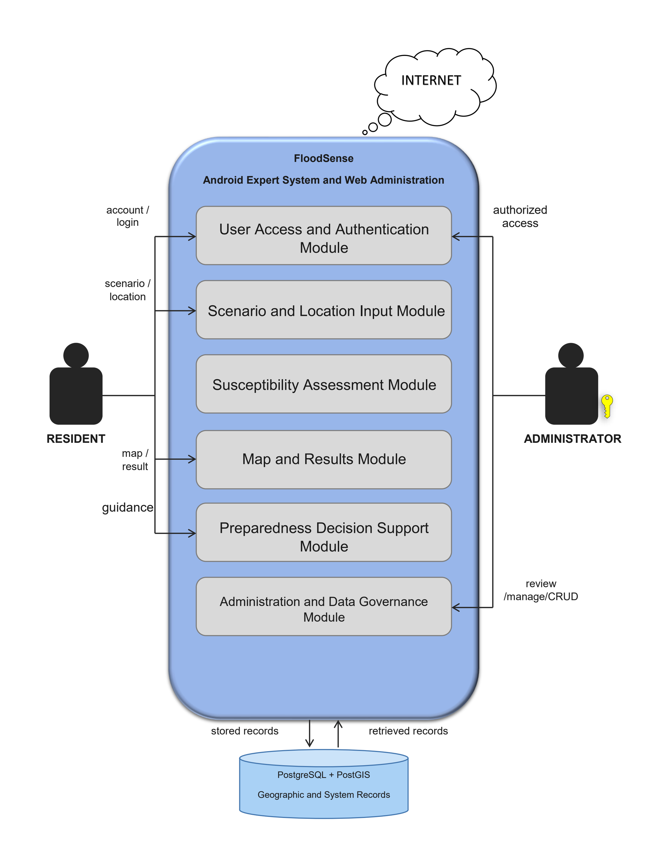

Figure 1. Theoretical Framework of FloodSense: FloodSense: An Android-Based Expert System for Flood Susceptibility Assessment and Pre-Event Preparedness in Bacoor City
Significance of the Study
FloodSense contributes an evidence-based approach to scenario-oriented flood preparedness by combining an explained susceptibility assessment with separate guidance and visible information boundaries.
For the Bacoor Disaster Risk Reduction and Management Office. The study may provide a complementary channel for presenting validated preparedness and evacuation-center information while retaining source, review, and audit records. It does not replace official warning, response, or emergency-command functions.
For the City Planning and Development Coordinator Office. The study demonstrates how appropriately authorized administrative and geographic information may support location-specific public communication while maintaining provenance and validation requirements.
For Bacoor City residents. The resident application provides a user-initiated process for confirming a hypothetical rainfall scenario and location, requesting an explained susceptibility result, viewing geographic context, and obtaining structured preparedness information.
For future researchers. The study documents the separation of deterministic assessment from preparedness guidance, the importance of authentication and role control, and the distinction among technical processing, scientific validation, and institutional authorization. Its procedures and findings require renewed validation before use in another locality.
Time and Place of the Study
The study is situated in Bacoor City, Cavite, the geographic setting for the resident needs assessment and institutional inquiry. Cavite State University–Bacoor City Campus serves as the academic base for system development and manuscript preparation. The location of the study corresponds to the residents and local offices whose information needs and responsibilities concern flood preparedness in Bacoor City.
The institutional interviews were conducted at the respective Bacoor City offices of the Bacoor City Disaster Risk Reduction and Management Office (BDRRMO) on May 12 and May 24, 2026, and the City Planning and Development Coordinator Office (CPDCO) on May 18, 2026. These visits preceded the principal study period and provided local institutional context for the Bacoor-focused research.
The principal study period began in September 2026 and is expected to continue through May 2027. The initial resident needs survey was completed on October 11, 2026, with 40 qualified respondents from 14 Bacoor City barangays. The schedule of study activities for September through December 2026 is presented in the Gantt Chart (see Appendix Table 1. Gantt Chart).
Scope and Limitation of the Study
FloodSense covers a connected Android application for Bacoor City residents and a browser-based administration system for authorized personnel. Its scope is pre-event, user-requested assessment of flood susceptibility for a selected place and hypothetical rainfall condition, together with separate preparedness support. The system is intended to help residents examine a scenario; it is not a report of an ongoing flood or an official forecast.
The resident scope includes authenticated access and privacy controls; user selection or confirmation of rainfall intensity and duration; barangay selection, a manually placed map pin, or optional one-time foreground location; confirmation of the resolved area; and an explicit request for assessment. The resident interface presents the selected inputs, a susceptibility classification when supported, an explanation of the rule-based result, and geographic context. If sufficient verified evidence is unavailable, the assessment may return an insufficient-information outcome instead of a class (see Appendix Figure 4. Use Case Diagram of FloodSense).
A deterministic Rule-Based Expert System evaluates the confirmed scenario and location. A distinct Decision Support System provides pre-event preparedness guidance and evacuation-center reference details without changing the susceptibility result. The interactive map offers administrative and geographic context, while the evacuation-center information identifies reference locations rather than confirming live occupancy, opening status, or safe travel. The assessment and guidance functions therefore support different decisions within the same resident application.
The administrative scope includes authorized review and management of permitted geographic and rainfall references, assessment parameters, preparedness content, evacuation-center records, source information, and publication or audit records. Ordinary administrators do not directly edit raw expert rules, their priorities, conflict-resolution logic, or algorithm code. Geographic records require source documentation and appropriate validation before they may be treated as authoritative. The interactions among residents, authorized administrators, and external data or expert sources are represented in the context diagram (see Appendix Figure 5. Context Diagram of FloodSense).
However, FloodSense is limited to pre-event, scenario-based assessment within its supported Bacoor City coverage and does not issue official forecasts, warnings, or evacuation orders. Its connected assessment, map, and evacuation-center functions require a compatible Android device and internet access. Foreground location is optional: residents may select a barangay or place a map pin instead, and the application does not track location in the background. Evacuation-center listings and straight-line distances do not confirm a center's opening status or capacity, road accessibility, or safe routes. The 47-barangay layer is an administrative reference rather than an officially validated flood-susceptibility dataset, and the rules and local data require scientific and institutional validation before authoritative use. If the selected location or hypothetical rainfall inputs lack sufficient verified supporting evidence, the system may report insufficient information instead of assigning a susceptibility classification.
Definition of Terms
The following terms are defined operationally as they are used in this study to ensure clarity and consistency throughout the research:
Android Application. The resident-facing FloodSense software developed with Flutter. It includes authentication, legal acceptance, onboarding, scenario and location confirmation, assessment requests, map/results presentation, structured preparedness guidance, nearest-center information, preferences, and account controls. It does not provide live alerts, assessment history, fully offline operation, or official warnings.
Color-Coded Susceptibility Levels. The visual scheme used on the dynamic map in which green indicates Low, yellow indicates Moderate, orange indicates High, and red indicates Very High flood susceptibility for the active scenario.
CPDCO (City Planning and Development Coordinator Office). The Bacoor City office that maintains planning and geographic information, including elevation, land-use, flood-hazard, and barangay-boundary materials relevant to the study.
Decision Support System (DSS). The component separate from the Rule-Based Expert System that presents published preparedness guidance and structured questions using the assessment context. It does not change the susceptibility result, issue an official warning or evacuation order, or make the user's final decision.
Expert System. A knowledge-based computer system that applies stored facts and conditional rules through an inference process. In FloodSense, it produces an explainable susceptibility class for a supported geographic area and rainfall scenario.
Flood Susceptibility. The relative potential of a supported geographic area to experience rainfall-related flooding under a user-confirmed scenario. FloodSense expresses the assessment as Low, Moderate, High, or Very High and identifies it as a research-system output rather than an official Bacoor City classification or real-time prediction.
Geographic Information System (GIS). A system for organizing, analyzing, and presenting information associated with geographic locations. FloodSense uses GIS functions for polygons, points, containment queries, interactive visualization, and evacuation-center locations.
GeoDjango. The geographic extension of Django used by FloodSense to represent spatial data and perform geographic operations between backend services and the PostGIS database.
Inference Process. The procedure that matches facts from the selected rainfall scenario and geographic area against validated rules in the knowledge base to derive a susceptibility conclusion and supporting explanation.
Knowledge Base. The structured collection of documented facts, conditional rules, geographic attributes, rainfall parameters, susceptibility categories, and provenance records used by the Expert System. These materials require appropriate expert and institutional validation before they can be treated as authoritative local evidence.
Rainfall Scenario Input. A user-selected hypothetical rainfall intensity and duration used to request a pre-event assessment. The choices are scenario labels, not automatically updated observations, official forecasts, or official warning thresholds.
PostGIS. The spatial extension of PostgreSQL used to store and query FloodSense geographic polygons, points, boundaries, selected locations, and evacuation-center coordinates.
Preparedness Provenance. Information identifying the source, validation status, responsible actor, relevant date, and version of a preparedness item or related record. Provenance permits users and administrators to distinguish approved, provisional, and unsupported information.
Rainfall Parameters. The supported combination of rainfall intensity and duration selected by the user and applied as scenario facts during Expert System assessment.
Rule-Based Expert System. An Expert System in which domain knowledge is represented as conditional rules. FloodSense evaluates applicable rules against known scenario and geographic facts to produce a susceptibility assessment.
Web Administration System. The custom browser-based interface used by authorized administrators for dashboards and permission-controlled workflows involving map and rainfall references, parameters, DSS content and structured flows, evacuation centers, data sources, review records, and audit history. It does not expose raw rule editing. Technical Django Admin is separate and is reserved for developer or research maintenance.

REVIEW OF RELATED LITERATURE
This chapter reviews foreign and Philippine literature and system studies that inform FloodSense's assessment and preparedness-support design. It considers the credibility of flood information, explainable rules, geographic and location data, and the communication of results.
Related Foreign Literature
Flood Assessment Credibility and Geographic Validation
Merz et al. (2024) argued that flood hazard and risk assessments should be validated for the decisions they are meant to support, rather than judged only by whether the calculations run. They organized validation at process, outcome, and impact levels and emphasized suitable data, transparent assumptions, and stakeholder participation. Thus, a repeatable result and a technically valid geographic boundary are necessary checks but do not alone establish the scientific credibility of a susceptibility class.
Their perspective concerns flood assessments generally, not a resident application, and supplies no Bacoor City parameters. For the proposed assessment, their framework supports documenting source records and geographic checks, seeking appropriate expert review, and stating limitations before a scenario result informs preparedness. In particular, an administrative reference boundary must not be presented as an approved flood-susceptibility dataset (Merz et al., 2024).
Rule-Based Decision Support and Explainable Inference
Credible inputs must also be connected to an understandable inference process. Papadopoulos et al. (2022) systematically reviewed 15 rule-based clinical decision-support publications. They described how encoded domain knowledge, case facts, and rule engines can produce case-specific advice, but found uneven use of standards and limited evidence of evaluated clinical outcomes. Although their field is health care, the review helps distinguish a knowledge base, fact matching, and an explanation of the resulting advice.
For the proposed rule-based assessment, the same governed geographic and rainfall facts should yield the same susceptibility result under the same rule version. An explanation should identify the matched basis and its limits, while ordinary administrators remain unable to rewrite raw conditions, priorities, or conflict handling. The clinical rules, outcomes, and evaluation evidence cannot be transferred to flooding or used to claim assessment accuracy in Bacoor City (Papadopoulos et al., 2022).
Actionable Flood-Risk Communication and Preparedness Support
An explainable result is useful to residents only when its meaning and possible actions are communicated clearly. Mostafiz et al. (2022) examined 50 freely available web-based flood-information portals alongside literature on mass media, citizen science, and social media. They found that many outlets addressed short-term information needs, whereas individualized information for longer-term planning remained limited. Their review separates the display of a map or warning from information that helps a person consider feasible protective actions.
This distinction informs the resident application's presentation of a confirmed hypothetical rainfall scenario, a susceptibility result with human-readable context, and separate preparedness guidance. The review does not provide a universal guidance formula, and its portals differ in jurisdiction, authority, and data from Bacoor City. These findings do not make a scenario-based research assessment an official forecast or autonomous warning service (Mostafiz et al., 2022).
Spatial Data Management with PostGIS
Location-specific information also depends on how geographic records are managed. The PostGIS Development Group (2025) documents geometry and geography types, spatial indexes, coordinate transformations, validity operations, and spatial relationship functions within PostgreSQL. These functions allow boundaries and location-linked records to be stored and queried alongside other application data. They are relevant to preserving geographic identifiers and relating resident-selected locations to administrative reference areas.
Database capability must not be confused with authority over the data. PostGIS is a spatial technology, not a susceptibility method or an approved dataset; storing a polygon and passing a geometry check do not verify its institutional origin or the scientific meaning of an assessment. The proposed system therefore requires separate provenance and authorization controls for boundaries, rainfall references, and assessment parameters (PostGIS Development Group, 2025).
Foreground Location and User Choice
Device location introduces a separate issue from spatial storage: when and how residents permit access to their position. Android Developers (2026) distinguishes foreground from background location access and explains approximate and precise permissions. A request made while a person actively uses an assessment differs from continual tracking. The platform guidance also recognizes that a user may grant only approximate location when the application's function permits it.
In the resident application, foreground location is an optional input to a user-requested assessment, while manual location selection remains available. The permission guidance informs this design choice but does not prove that every device will identify the correct barangay. Device accuracy, boundary quality, resident confirmation, and privacy controls require separate checks (Android Developers, 2026).
Related Local Literature
Philippine Flash-Flood Susceptibility Mapping
Philippine mapping research makes the limits of geographic transfer concrete. Puno et al. (2022) mapped flash-flood susceptibility in Barangay Bukang Liwayway, Kibawe, Bukidnon using GIS and frequency-ratio analysis. Their publication described 160 recorded flood points, nine conditioning factors, remotely sensed land-cover inputs, and field checks with local residents. The resulting classes therefore depended on particular observations, selected factors, processing steps, and validation, rather than on map coloring alone.
That geographically isolated barangay has terrain and data conditions unlike Bacoor City's urban setting. Its frequency-ratio weights, classes, and mapped results cannot be adopted as the proposed system's rules without local evidence and expert validation. The study instead supports documenting provenance and distinguishing a research susceptibility layer from an administrative reference boundary (Puno et al., 2022).
Flood Mitigation in Cavite and the Imus River Basin
Within Cavite, the Japan International Cooperation Agency (2021) reported the inauguration of Imus River Basin flood-mitigation facilities, including retarding basins associated with Bacoor and Imus. Its account explained their intended storage of storm runoff and noted overflow affecting low-lying tributary areas. The report establishes the relevance of watershed behavior and infrastructure to the local setting. It is not a resident-system evaluation or a barangay-level susceptibility dataset.
The existence of those facilities cannot establish a household's exposure or the conditions at every Bacoor location. Nor does the report provide assessment rules or a current, validated local susceptibility layer. It supplies geographic context for the research while showing why engineering mitigation and a public-facing, hypothetical-scenario assessment answer different questions (Japan International Cooperation Agency, 2021).
UP NOAH and Public Hazard Maps
Local access to geographic hazard information is illustrated by UP NOAH. Dabu (2024), writing in a University of the Philippines institutional article, described its online display of flood, landslide, and storm-surge hazards for a user's area of interest. This example shows how place-oriented hazard information can be made accessible to the public. The article is institutional literature, not an IMRaD evaluation of the platform, and supplies neither a software-development model nor Bacoor-specific assessment rules.
UP NOAH is therefore a useful reference for map-based risk communication, but its documented purpose and authority differ from FloodSense. The latter asks a resident to confirm a hypothetical rainfall scenario and request a deterministic susceptibility assessment with separate preparedness guidance. That research output must not be presented as an official forecast or warning, and the institutional article does not establish that NOAH data were incorporated into the proposed application (Dabu, 2024).
HazardHunterPH and Institutional Data Authority
The authority of a geographic result is clearer when its sources are identified. DOST-PHIVOLCS (2023) described HazardHunterPH as a GeoRisk Philippines application for site-specific multi-hazard assessment using official hazard and related information from participating Philippine agencies. Its presentation illustrates the importance of naming sources and specifying an assessment's intended use. The cited account is official platform documentation, not a peer-reviewed system study with a transferable evaluation method.
The proposed research application can draw on that source transparency and place-based presentation without claiming equivalent institutional status. A site-specific assessment backed by named agencies is not interchangeable with an unapproved project layer. Likewise, technical geometry validation of a 47-barangay administrative reference does not make it an official flood-hazard map (DOST-PHIVOLCS, 2023).
Philippine Guidance on Mobile Permissions
Place-based information also requires attention to residents' control over device permissions. The National Privacy Commission (2021) advised developers to request minimum permissions, ask in context, and preserve user choice when optional access is denied. Although its advisory concerned instant-messaging applications, it explicitly discussed location sharing among app permissions. The principle helps assess whether a resident location request is proportional to a specific task.
For the resident application, this means seeking foreground location only during an active, user-initiated assessment and retaining manual alternatives. The advisory does not demonstrate that the application has passed a privacy audit or that an individual GPS reading is accurate. Implementation, consent behavior, and location accuracy require their own testing evidence (National Privacy Commission, 2021).
Related Foreign Studies
Design and Implementation of Real-Time Flood Early Warning System (FEWS) Based on IoT Blynk Application: An Arduino- and GSM-Based Mobile Flood-Warning System
Wisudawan (2021) investigated a mobile-connected Flood Early Warning System for a reservoir at Universitas Islam Indonesia in Sleman, Yogyakarta. The work addressed the need to observe local environmental conditions and communicate warning levels to a mobile user. Its purpose was continuous site monitoring, not the assessment of a hypothetical rainfall scenario.
The researcher assembled an Arduino Nano with rainfall, water-level, temperature, and humidity sensors, GSM communication, and the Blynk Android application. The prototype was checked in sensor tests and then observed at the reservoir for 30 days. Readings were categorized into Normal, Advisory, Watch, and Warning states; the source did not name a formal software-development life-cycle model.
During the observation period, the reported mean temperature was 28.6 degrees Celsius, mean humidity was 63.7%, and mean water level was 54.5 centimeters. The paper documented transmission and display of readings and warning states. No flood occurred during field observation, so the study did not demonstrate warning performance during an actual flood event.
The prototype illustrates how environmental measurements can be presented understandably on a mobile interface. Its one-reservoir setting, short observation period, and sensor thresholds limit transferability to other places. FloodSense instead uses a resident-confirmed hypothetical scenario and deterministic susceptibility rules; the Indonesian sensor readings cannot validate Bacoor City conditions.
A User Experience Evaluation of a Mobile Application for Disseminating Site-Specific Impact-Based Flood Warnings: The A4alerts App: A Mobile Application for Site-Specific Impact-Based Flood Warnings
Meléndez-Landaverde and Sempere-Torres (2025) examined A4alerts, a mobile application for disseminating site-specific, impact-based flood warnings in Catalonia, Spain. Their research asked whether users considered the application and its warning-related functions useful in an emergency context. The app drew on an operational warning environment rather than a stand-alone hypothetical susceptibility exercise.
Seventy-six civil-protection, emergency-response, and local stakeholders completed an online interactive scenario experiment between January and March 2022. The researchers assessed perceived usefulness, functional appropriateness, and willingness to adopt the app and compared feature rankings using Friedman's test and Bonferroni-adjusted Wilcoxon comparisons. The participant experience was a demonstration, not observation of behavior during a real flood.
Ninety-seven percent of participants considered A4alerts useful during flood emergencies, while 93% said they would use or recommend it. Site-specific impact warnings, official regional warnings, and a self-protection checklist were among the most valued functions. These are reported perceptions of the recruited participants, not evidence of an observed reduction in flood losses.
The study supports careful presentation of place-specific information and actionable guidance. Its stakeholder sample, Catalan warning infrastructure, and scenario experiment constrain generalization to Bacoor City residents. FloodSense can draw on its communication lessons but does not disseminate official operational warnings or inherit the evaluated app's performance.
Real-Time Flood Forecasting and Warning: A Comprehensive Approach toward HCI-Centric Mobile App Development: A Human-Centered Mobile Flood-Forecasting and Warning Prototype
Alsabhan and Dudin (2023) developed and evaluated a human-computer-interaction framework and prototype for mobile real-time flood forecasting and warning. The study focused on the tasks and information needs of front-end users, weather-station users, and administrators. Its research problem concerned a multi-role forecasting environment rather than pre-event assessment initiated by a resident.
Activity theory and scenario-based design guided nominal-group sessions with five prospective users and five experts. Participants generated 63 situations, from which 12 priority scenarios informed requirements and prototype tasks. The researchers evaluated task performance and satisfaction across usefulness, ease of use, learnability, satisfaction, and overall experience; no Agile, Waterfall, or other SDLC was stated as the study's development model.
The process produced 87 initial requirements and six additional requirements after testing, for a total of 93. Mean satisfaction-category scores ranged from 3.93 to 4.08, although some analytical tasks were harder for participants. The reported prototype and evaluation therefore give evidence about requirements and interaction quality, not about forecast accuracy in Bacoor City.
This study shows why role-specific access and understandable interactions matter in a flood-information application. Its small participant groups and forecasting architecture limit wider inference. FloodSense shares the need for comprehensible outputs and permissions, but its deterministic, resident-requested susceptibility assessment is separate from real-time forecasting and warning.
Developing a Climate-Smart Web GIS App for Multi-Hazard Early Warning against Climate-Based Disaster Risks: A Tanzanian Web GIS for Flood and Drought Early Warning
Msusa et al. (2025) investigated a climate-smart Web GIS application for multi-hazard early warning in Tanzania. Flood analysis focused on Dar es Salaam, while drought analysis focused on Dodoma. The authors sought to bring modeled hazard information and local knowledge into an accessible geographic application for planning and warning purposes.
For flooding, the researchers used Height Above Nearest Drainage analysis, GloFAS forecast information, and community-mapped flood points for spatial comparison. For drought, they used geospatial climate inputs and a ConvLSTM model. The paper expressly identified Rapid Application Development as its Web GIS development process; these hydrological, machine-learning, and development procedures served different methodological roles.
The mapped flood points showed qualitative spatial agreement with the flood-model output. The reported median ROC-AUC of 0.87 and median F1 score of 0.81 refer to the drought model, not to the flood analysis. The application brought these multi-hazard outputs together in a Web GIS interface.
The study demonstrates the value of combining spatial analysis, local validation, and accessible map presentation. Its forecast data, modeling choices, and Tanzanian geographic conditions cannot be transferred directly to Bacoor City. FloodSense uses deterministic scenario-based assessment and cannot claim the study's early-warning or machine-learning results as its own.
Near Real-Time Responsive Flood Event Representation: An Open-Source Interactive Web Application Architecture: A Melbourne Digital-Twin Flood Display
Turner and Sun (2024) developed an open-source web-application architecture for representing near-real-time flood events in the Moonee Valley and Maribyrnong areas of Melbourne, Australia. The research problem concerned how river-height and rainfall streams could be joined with a digital city model to display developing events and their potential impacts for decision-makers.
The technical procedure assembled government elevation and building data, administrative boundaries, open water polygons, and Melbourne Water station feeds in a spatial database. A web interface combined these data with event triggers, geospatial queries, and three-dimensional visualization. The source describes this architecture and its proof-of-concept implementation; it does not name an SDLC model.
The authors reported a functioning spatial back end, near-real-time data connections, an interactive front end, and on-demand impact statistics. The paper presents a prototype architecture rather than evidence of resident acceptance, warning accuracy during all floods, or operational deployment throughout Melbourne.
Its combination of spatial storage, data-source identification, and accessible map presentation informs the proposed application's geographic design. The live sensors, impact analytics, Australian data, and emergency-event purpose cannot be transferred to Bacoor City or attributed to the user-requested, hypothetical-scenario assessment (Turner & Sun, 2024).
Related Local Studies
Development of a Water Level Data Logging System with Web-Based Data Visualization for Remote Monitoring Stations: A Water-Level Monitoring and Web-Visualization System
Añana and Beltran (2024) developed a water-level data-logging device with a web-based time-series display to support remote monitoring by local authorities in the Philippines. Their study addressed the presentation of measured water conditions at monitoring stations. It did not assess a resident-selected hypothetical rainfall scenario.
The authors described Systems Development Life Cycle stages of requirements specification, analysis, interface design, development, and testing, without naming a more specific software-development model. They gathered requirements through interviews with barangay and city disaster-risk offices, developed a sensor-linked web chart, and tested water-level display in a tank, at a seawall, and at a riverside. These are documented development and technical procedures, not evidence of a resident-user evaluation.
The reported tank and seawall tests displayed changing water levels and their corresponding categories in the web interface. The riverside test took place under calm conditions and showed a green category; the paper did not evaluate warning performance during a flood. Its documented contribution is remote visualization of sensor readings and category information, not verified reduction of flood harm.
The study illustrates how time-series display and status categories can make measured conditions easier to interpret. Its water-level sensor, test settings, and site-specific category thresholds differ from FloodSense's resident-requested susceptibility assessment and separate preparedness guidance. The tested readings and thresholds cannot validate classifications for Bacoor City, and the source does not establish system-wide operational effectiveness.
Isabela City Flood Monitoring System Using Arduino and GSM Module: An Arduino and GSM Flood-Monitoring and SMS-Warning System
Carpio, Asnaul, Said, and Amerin (2022) developed an Arduino and GSM flood-monitoring system for Riverside Barangay in Isabela City, Basilan. The system was intended to observe water conditions and communicate warning signals to local disaster personnel. It addressed a local monitoring problem rather than the interpretation of a hypothetical resident-chosen rainfall scenario.
The authors explicitly used an Agile Development Model for incremental system construction and a quantitative survey design for evaluation. Twenty City Disaster Risk Reduction and Management Office personnel participated in a demonstration and initial device test. They assessed functionality, design, security, efficiency, and reliability, making the survey an evaluation of the prototype under the reported conditions.
The paper reported an overall mean of 3.70, interpreted by its authors as Acceptable, and described warning-signal operation during testing. It also reported that battery operation was limited to approximately ten hours. These results describe the tested device and evaluator group; they do not show sustained warning performance across Isabela City.
The Philippine setting provides a useful comparison for local disaster-information systems and for distinguishing development method from evaluation design. However, its hardware, threshold conditions, respondent group, and measured outcomes cannot be transferred to Bacoor City. FloodSense does not continuously monitor water level or send autonomous SMS warnings.
iAlerto: A Web and Mobile Alert System for Pasig City Disaster Risk Reduction Management Office (PCDRRMO) with mobile GPS service integration: A Resident Incident-Reporting and Response Platform
Goh et al. (2023) developed iAlerto for resident incident reporting and PCDRRMO response in Pasig City. The problem was the timely collection of emergency reports and communication among residents, barangay staff, rescuers, and administrators. Its location function identifies the position of a reported incident rather than computing flood susceptibility from a hypothetical rainfall scenario.
The authors expressly used Scrum for software development and described separate web and mobile roles. They evaluated functionality with 20 information-technology professionals and 20 residents or DRRMO personnel using ISO 9126 functionality criteria. Their source reports the development procedure, users, evaluation method, and system output rather than merely listing programming tools.
The published system included incident reports, GPS-linked location, administrative records, announcements, and evacuation-center management. Respondents gave an overall perceived-functionality mean of 4.48. The authors recommended adding an SMS module for people without internet access, indicating that this feature was not part of the reported evaluated system.
iAlerto is a Philippine example of role-specific emergency information and location-linked reporting. Its Pasig sample, live incident-response function, and perceived functionality result do not establish performance in Bacoor City. FloodSense instead supports pre-event, user-requested susceptibility assessment and separately presented preparedness information (Goh et al., 2023).
Development of an Integrated Natural and Socioeconomic Indicators Monitoring System for Bulacan Using Earth Intelligence Tools: A Web-Based Flood Monitoring and Decision-Support System
Pascual and Leonen (2025) developed an integrated flood-risk monitoring system for Bulacan and evaluated the platform with local government and disaster-risk stakeholders in Meycauayan City. The study sought to combine environmental, geographic, and socioeconomic information in a web-based dashboard for localized risk assessment and decision support. Its system receives observed or externally supplied data rather than a resident-confirmed hypothetical rainfall scenario.
The authors expressly used Design and Development Research as their research design and the Agile Development Lifecycle as their software-development process. They integrated satellite rainfall, dam-discharge information, geographic hazard layers, and socioeconomic indicators, then evaluated a Random Forest flood-alert classifier using an 80/20 training-and-test split. The paper also reports interface and stakeholder evaluation; these research, development, and technical methods should not be conflated.
The paper reports a web dashboard with geographic flood-risk presentation and a flood-alert classifier with 95% test accuracy, 0.60 precision, 0.73 recall, and a 0.66 F1 score. It also reports stakeholder feedback on navigation and decision-support information. These are results under the authors’ Bulacan data and evaluation conditions, not independently established performance in Bacoor City.
The study illustrates how a Philippine local-government information system can combine spatial display, data integration, modeling, and stakeholder review. Its dependence on internet connectivity, gaps in dam telemetry, class imbalance, and location-specific inputs limit transferability. FloodSense does not adopt automatic data ingestion, machine-learning prediction, or autonomous flood alerts, and the Bulacan findings cannot validate its deterministic Bacoor City assessment.
Flood Vulnerability Assessment of Road Network in San Fernando, Pampanga for the Development of Automatic Local Flood Alert and Recording with Mapping Application (ALARMA): A Road-Flood Mapping and Alert Prototype
Geron et al. (2025) assessed road-network flood vulnerability in San Fernando, Pampanga and developed ALARMA to display road conditions and send water-level alerts. The research focused on mobility and flood-related travel disruption. Its road and alert purpose differs from FloodSense's location-specific, pre-event resident susceptibility result.
The authors described an exploratory sequential mixed-methods design, AHP with ratio weighting for rainfall, elevation, waterway proximity, and traffic flow, and QGIS-based spatial analysis. Five government-agency experts provided factor comparisons. The team then built a web map and alert device and used simulated water-level changes and an ISO 25010-based questionnaire to examine the prototype.
The paper reports a mapped road-vulnerability output and website/SMS status changes during 30 simulated update events. No actual flood occurred during that system test, so the reported simulation performance must not be treated as field accuracy during real floods. The paper also limits its map to four available factors and notes omitted drainage or land-use conditions.
ALARMA demonstrates how local data, expert weighting, geographic display, and prototype checks can be combined. Its Pampanga road network, AHP weights, device thresholds, and alert procedures are not valid substitutes for Bacoor City susceptibility rules. FloodSense neither routes motorists nor issues automatic water-level alerts (Geron et al., 2025).
Comparative Synthesis of Related Studies
Tables 1 and 2 compare five foreign and five Philippine system studies by their documented methods, objectives, and contributions. The foreign studies show different ways of presenting geographic flood information: sensor-based warning (Wisudawan, 2021), evaluated site-specific warning communication (Meléndez-Landaverde & Sempere-Torres, 2025), role-centered forecasting interactions (Alsabhan & Dudin, 2023), multi-hazard Web GIS (Msusa et al., 2025), and a near-real-time spatial display (Turner & Sun, 2024). Their shared concern is understandable, place-related information, but they use different data sources and serve monitoring or operational-warning purposes rather than a resident-confirmed hypothetical susceptibility assessment.
The Philippine studies likewise address distinct local tasks: remote water-level visualization (Añana & Beltran, 2024), Arduino/GSM warnings (Carpio et al., 2022), GPS-linked incident reporting (Goh et al., 2023), an integrated Bulacan risk dashboard (Pascual & Leonen, 2025), and road-vulnerability mapping with simulated alerts (Geron et al., 2025). These systems demonstrate the value of geographic presentation, role-specific access, and local testing, while also showing limitations of site-specific thresholds, simulated events, uneven data availability, and small or specialized evaluator groups. Their methods and reported results cannot be treated as validated Bacoor City susceptibility rules or evidence that the proposed application has been evaluated by residents.
Table 1. Comparison of related foreign studies
SYSTEM | AUTHOR(S)  /YEAR | METHODOLOGY | OBJECTIVES | CONTRIBUTIONS
Design and Implementation of Real-Time Flood Early Warning System (FEWS) Based on IoT Blynk Application: An Arduino- and GSM-Based Mobile Flood-Warning System | Wisudawan (2021) | Site survey; sensor-system design and testing; 30-day reservoir observation of rain, temperature, humidity, and water level. | The study aimed to build and implement a real-time IoT flood early-warning system with mobile access. | It produced four warning states and reported 30-day mean sensor values; no flood occurred during observation.
A User Experience Evaluation of a Mobile Application for Disseminating Site-Specific Impact-Based Flood Warnings: The A4alerts App: A Mobile Application for Site-Specific Impact-Based Flood Warnings | Meléndez-Landaverde and Sempere-Torres (2025) | Online scenario-based user experiment with 76 participants; Likert evaluation, ranking, Friedman test, and Wilcoxon post hoc analysis. | The study evaluated A4alerts' usefulness, suitability, and potential adoption among users. | It found 97% perceived usefulness and ranked site-specific warnings, official warnings, and self-protection guidance highest.
Table 1. Continued
SYSTEM | AUTHOR(S)  /YEAR | METHODOLOGY | OBJECTIVES | CONTRIBUTIONS
Real-Time Flood Forecasting and Warning: A Comprehensive Approach toward HCI-Centric Mobile App Development: A Human-Centered Mobile Flood-Forecasting and Warning Prototype | Alsabhan and Dudin (2023) | Activity theory and scenario-based design; nominal groups of five users and five experts; prototype task and satisfaction evaluation. | The study aimed to derive HCI requirements and evaluate a mobile real-time flood-forecasting and warning prototype. | It identified 93 design requirements, three user groups, and mean satisfaction scores from 3.93 to 4.08.
Developing a Climate-Smart Web GIS App for Multi-Hazard Early Warning against Climate-Based Disaster Risks: A Tanzanian Web GIS for Flood and Drought Early Warning | Msusa et al. (2025) | Rapid Application Development (Web GIS); HAND/GloFAS flood analysis and participatory mapping; ConvLSTM drought modeling. | The study aimed to develop a localized multi-hazard Web GIS early-warning application for Tanzania. | It reported strong spatial agreement for flood validation and drought-model median ROC-AUC 0.87 and F1 0.81.
Near Real-Time Responsive Flood Event Representation: An Open-Source Interactive Web Application Architecture: A Melbourne Digital-Twin Flood Display | Turner and Sun (2024) | Technical method: spatial database, live-data API integration, event-triggered geospatial queries, and interactive digital-twin prototyping. | The study aimed to demonstrate an open-source web architecture for near-real-time flood-event display and impact information in Melbourne. | It reported a working spatial back end, sensor-data connections, interactive visualization, and on-demand impact statistics as a proof of concept.
Table 2. Comparison of related local studies
SYSTEM | AUTHOR(S)  /YEAR | METHODOLOGY | OBJECTIVES | CONTRIBUTIONS
Development of a Water Level Data Logging System with Web-Based Data Visualization for Remote Monitoring Stations: A Water-Level Monitoring and Web-Visualization System | Añana and Beltran (2024) | SDLC stages: requirements interviews, analysis, interface design, sensor/web development, and tank, seawall, and riverside tests. | The study aimed to log measured water levels and present time-series trends remotely to support local monitoring. | The web chart displayed test readings and status categories; no flood-event warning performance was evaluated.
Isabela City Flood Monitoring System Using Arduino and GSM Module: An Arduino and GSM Flood-Monitoring and SMS-Warning System | Carpio et al. (2022) | Agile Development Model (software development); quantitative survey and device test with 20 CDRRMO personnel. | The study aimed to develop an Arduino/GSM system that monitors water level and sends SMS warnings. | It obtained an overall mean of 3.70, interpreted as Acceptable, and documented a ten-hour battery limit.
Table 2. Continued
SYSTEM | AUTHOR(S)  /YEAR | METHODOLOGY | OBJECTIVES | CONTRIBUTIONS
iAlerto: A Web and Mobile Alert System for Pasig City Disaster Risk Reduction Management Office (PCDRRMO) with mobile GPS service integration: A Resident Incident-Reporting and Response Platform | Goh et al. (2023) | Scrum (software development); functionality assessment by 40 IT, resident, and DRRMO evaluators using ISO 9126 criteria. | The study aimed to improve Pasig residents' incident reporting and PCDRRMO response through linked web and mobile applications. | It reported GPS-linked incident reports, administrative and evacuation-center records, announcements, and a perceived-functionality mean of 4.48.
Development of an Integrated Natural and Socioeconomic Indicators Monitoring System for Bulacan Using Earth Intelligence Tools: A Web-Based Flood Monitoring and Decision-Support System | Pascual and Leonen (2025) | Design and Development Research (research design); Agile Development Lifecycle (software process); spatial integration and Random Forest testing. | The study aimed to integrate environmental and socioeconomic indicators into a Bulacan flood-risk dashboard for local decision support. | It reported a geographic dashboard and flood-alert classifier with 95% test accuracy, 0.60 precision, and 0.73 recall.
Flood Vulnerability Assessment of Road Network in San Fernando, Pampanga for the Development of Automatic Local Flood Alert and Recording with Mapping Application (ALARMA): A Road-Flood Mapping and Alert Prototype | Geron et al. (2025) | Exploratory sequential mixed methods; expert AHP-ratio weighting, QGIS road analysis, web/device prototyping, and simulated alert tests. | The study aimed to map vulnerable San Fernando roads and develop a flood-status and alert application for motorists. | It reported a road-vulnerability map and website/SMS status updates in 30 simulated events; no actual flood occurred during the test.
Table 3 compares only features established in the ten inspected studies with features belonging to the proposed system's defined scope. The proposed application combines explicit scenario and location input, deterministic and explainable susceptibility assessment, geographic presentation, and separate preparedness guidance; the reviewed systems more often emphasize observed conditions, forecasts, alerts, or incident response. This comparison identifies differences in purpose and documented function, not superiority, predictive accuracy, deployment, or implementation maturity. A blank cell means the inspected source did not establish that feature. Local source validation and testing remain necessary before Bacoor-specific results can be relied upon.
Table 3. Comparison of developed study to the other existing systems.
FEATURES | EXISTING SYSTEMS |  |  |  |  |  |  |  |  |  | Proposed  System
 | S1 | S2 | S3 | S4 | S5 | S6 | S7 | S8 | S9 | S10
User-facing mobile or web interface | ✓ | ✓ | ✓ | ✓ | ✓ | ✓ |  | ✓ | ✓ | ✓ | ✓
Geographic or map-based presentation |  | ✓ |  | ✓ | ✓ |  |  | ✓ | ✓ | ✓ | ✓
Location-specific information |  | ✓ | ✓ | ✓ | ✓ | ✓ | ✓ | ✓ | ✓ | ✓ | ✓
User-selected hypothetical rainfall scenario |  |  |  |  |  |  |  |  |  |  | ✓
Deterministic rule-based susceptibility assessment |  |  |  |  |  |  |  |  |  |  | ✓
Human-readable hazard or assessment context | ✓ | ✓ | ✓ | ✓ | ✓ | ✓ | ✓ | ✓ | ✓ | ✓ | ✓
Preparedness or self-protection guidance |  | ✓ |  |  |  |  |  | ✓ |  |  | ✓
Administrative management interface |  |  |  |  |  |  |  | ✓ |  |  | ✓
Legend:
✓ - included in the system
S1 - Design and Implementation of Real-Time Flood Early Warning System (FEWS) Based on IoT Blynk Application
S2 - A User Experience Evaluation of a Mobile Application for Disseminating Site-Specific Impact-Based Flood Warnings: The A4alerts App
S3 - Real-Time Flood Forecasting and Warning: A Comprehensive Approach toward HCI-Centric Mobile App Development
S4 - Developing a Climate-Smart Web GIS App for Multi-Hazard Early Warning against Climate-Based Disaster Risks
S5 - Near Real-Time Responsive Flood Event Representation: An Open-Source Interactive Web Application Architecture
S6 - Development of a Water Level Data Logging System with Web-Based Data Visualization for Remote Monitoring Stations
S7 - Isabela City Flood Monitoring System Using Arduino and GSM Module
S8 - iAlerto: A Web and Mobile Alert System for Pasig City Disaster Risk Reduction Management Office (PCDRRMO) with mobile GPS service integration
S9 - Development of an Integrated Natural and Socioeconomic Indicators Monitoring System for Bulacan Using Earth Intelligence Tools
S10 - Flood Vulnerability Assessment of Road Network in San Fernando, Pampanga for the Development of Automatic Local Flood Alert and Recording with Mapping Application (ALARMA)
METHODOLOGY
This chapter describes the materials, research method, participants, and statistical treatment used to investigate flood-information needs and design and develop FloodSense. Design and Development Research is the study's research design; Evolutionary Prototyping is the software-development model used to construct and refine the application.
Materials
Research materials comprised the bilingual initial needs-assessment questionnaire and consent notice, Google Forms and face-to-face collection materials, the exported responses of 40 purposively selected qualified adults, institutional interview guides, consented recordings and transcripts, request letters, relevant school and official documents, and the scholarly sources used to define the problem and requirements. Google Forms collected online responses, while face-to-face procedures provided the other collection mode. The handwritten task board and Excel tracker recorded work items, while GitHub supported sharing and versioning of development work. These materials supported needs identification and requirements analysis; the initial survey was not a post-use application evaluation.
The principal development computer was an ASUS laptop with an Intel Core i7-1065G7 processor, integrated Intel Iris Plus graphics, and 20 GB of RAM. It was used for development, local service operation, document preparation, and technical checking. An Android smartphone provided a physical device for resident-interface checks. These are the two hardware types used for the study's development and testing activities.
The resident application used Flutter and Dart; Python with Django and Django REST Framework supported backend and web-administration functions; PostgreSQL/PostGIS provided relational and spatial storage. Git and GitHub maintained shared source changes. Mapping components supported geographic presentation, and the browser provided access to the administration interface. These software tools supported implementation and testing, but their presence does not itself validate geographic data, expert rules, or system usability.
Method
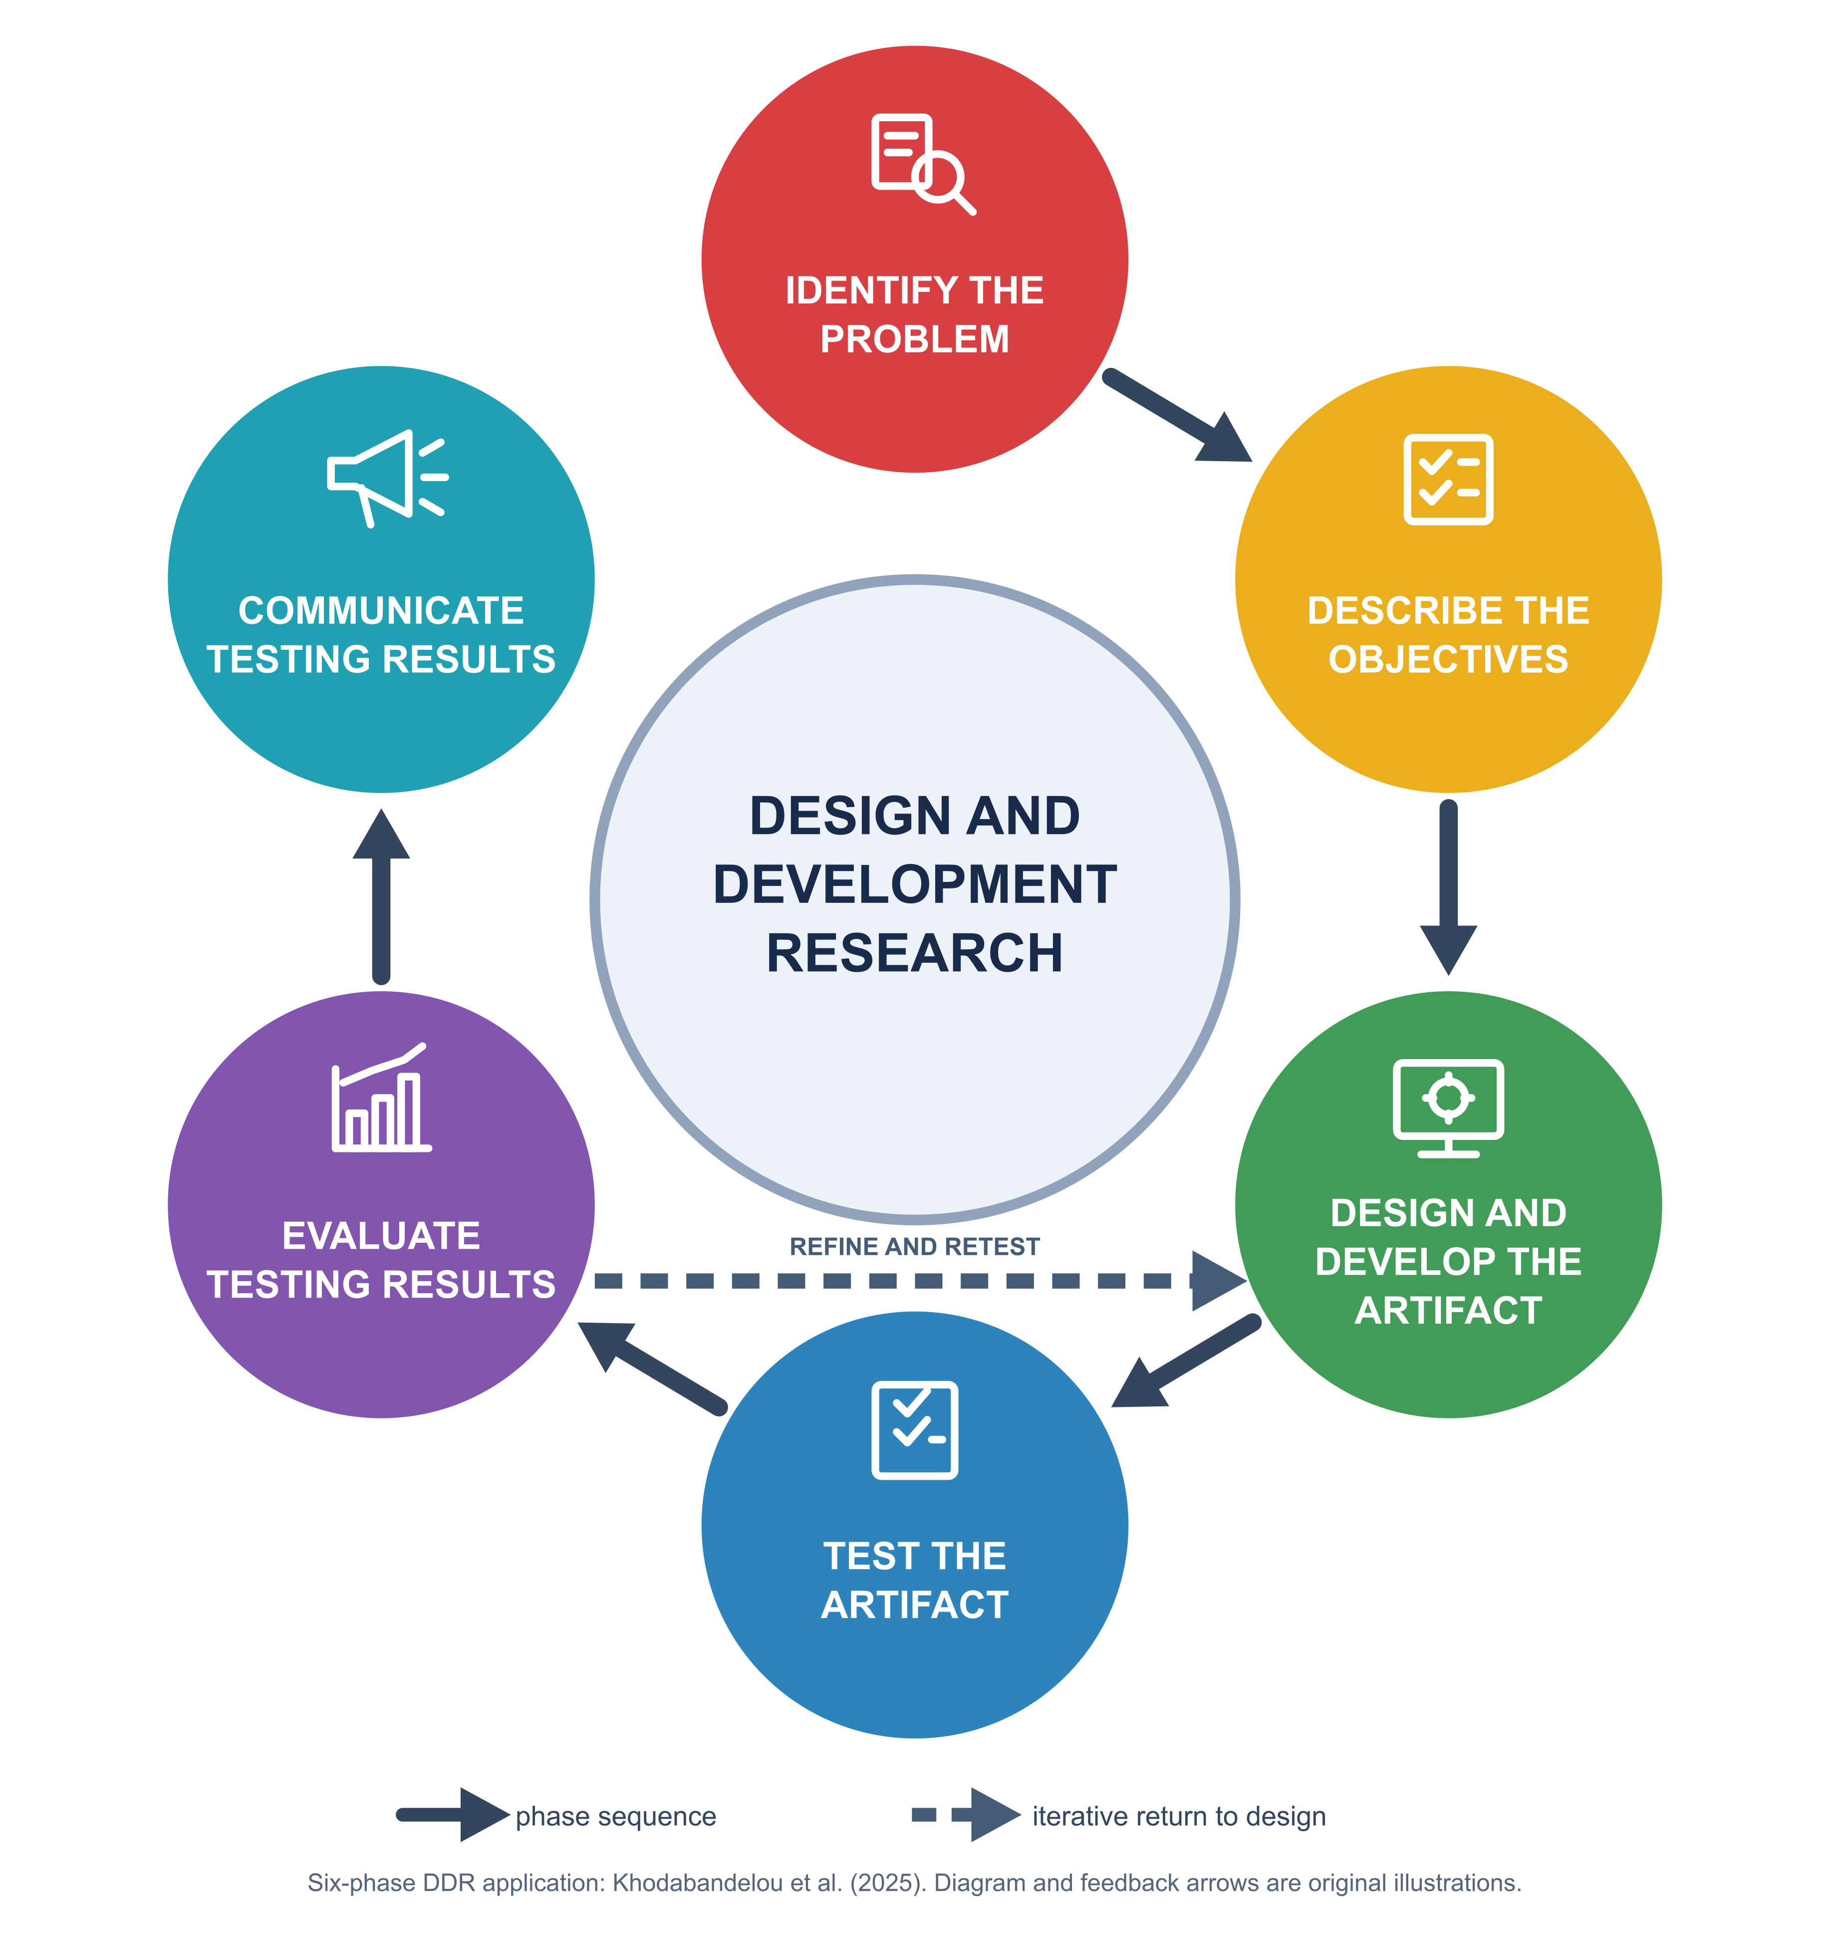
Figure 2. Design and Development Research (Khodabandelou et al., 2025).

The study uses Design and Development Research as its research methodology. Khodabandelou et al. (2025) applied a six-phase approach comprising problem identification, objective definition, artifact design and development, artifact testing, evaluation of testing results, and communication of results. Their publication credits the framework to Ellis and Levy (2010). Figure 2 illustrates the cited phases using the researchers' own design. Its straight return arrow represents the formative refinement of the FloodSense artifact.
Design and Development Research organizes the inquiry from the identification of a research problem to the communication of supported findings. Evolutionary Prototyping guides software development within the third research phase and connects construction, technical testing, review, and refinement across Phases 3 to 5. The handwritten task board and Excel tracker organized work items, while GitHub maintained shared development changes. Intended-user evaluation and deployment will be undertaken as later activities.
Identify the Problem
The approved study concept and relevant literature framed the initial inquiry. Recorded and transcribed institutional interviews with BDRRMO and CPDCO preceded the October 2026 resident needs survey and supplied institutional perspectives on flood information, data authority, and preparedness. The purposive survey gathered responses from 40 qualified Bacoor City residents through Google Forms and face-to-face collection. It documented reported flood experiences, information difficulties, and preparedness needs; it did not assess the application after use (see Appendix 4. Initial Resident Needs-Assessment Questionnaire, Blank Copy).
The institutional interviews helped distinguish information needs from the authority and validation required for geographic and susceptibility data. Their suggestions informed problem analysis but did not constitute approval of a susceptibility dataset, validation of the algorithm, or evidence of resident acceptance.
Describe the Objectives
The research objectives translated identified resident needs and the approved study scope into requirements for location and hypothetical rainfall input, explainable deterministic susceptibility assessment, separate preparedness guidance, geographic presentation, privacy, and authorized administration. Candidate requirements were checked against source availability, data authority, and technical constraints. The objectives did not establish that every proposed function or information source was operational.
Design and Develop the Artifact
To design and develop FloodSense, the researchers used Evolutionary Prototyping to construct and refine the same application through successive working versions. The approved scope and institutional input guided early development, while the later resident needs assessment supported further requirements review. The model guided construction in Design and Development Research Phase 3 and connected it with technical testing and refinement in Phases 4 and 5. Figure 3 presents the development stages described by Saad et al. (2023). Formal customer evaluation and final deployment will be undertaken as later activities.
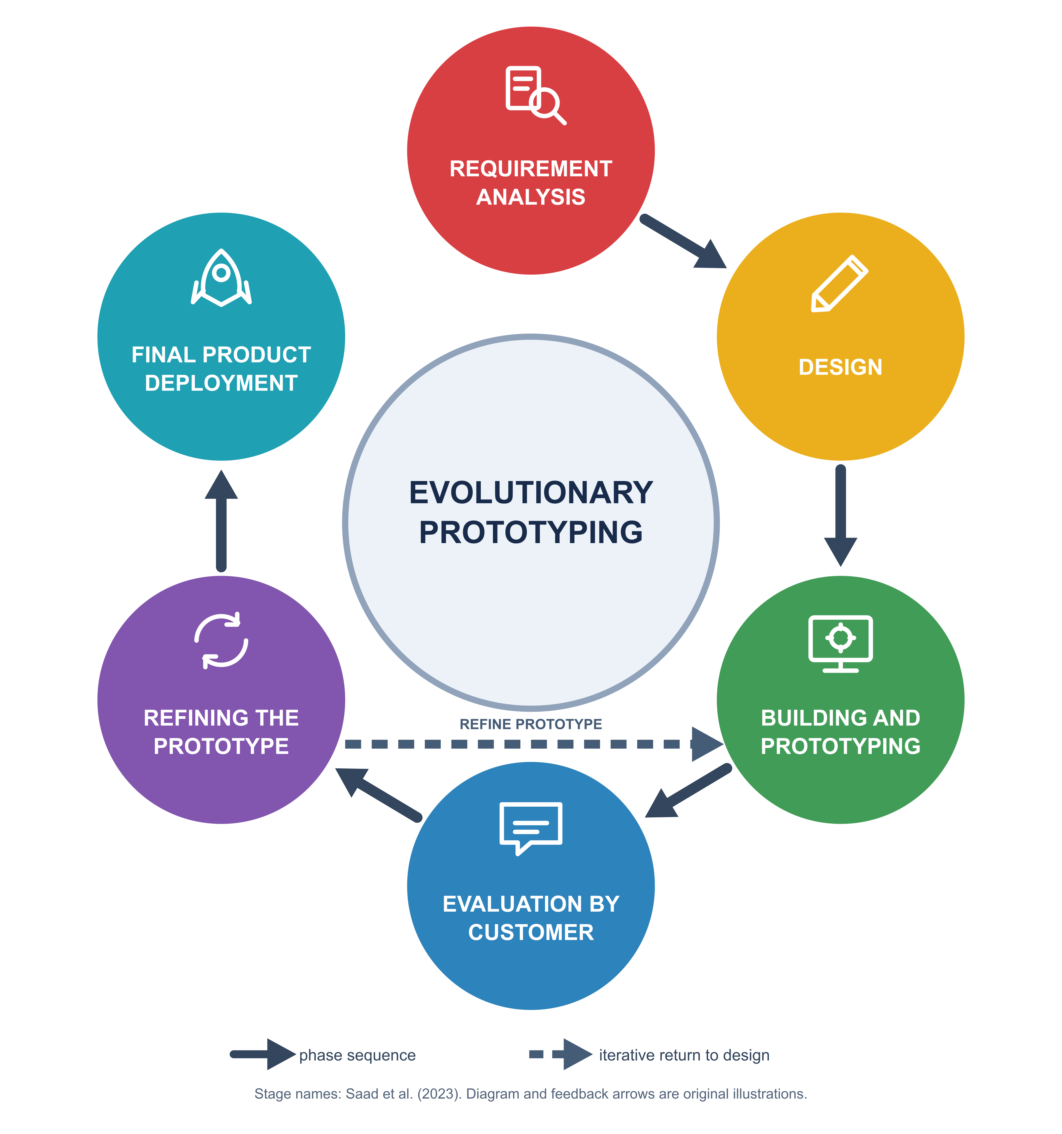
Figure 3. Evolutionary Prototyping process (Saad et al., 2023).

The researchers first organized the application around a resident-requested assessment. The resident would confirm a location and hypothetical rainfall scenario before requesting a result, with susceptibility assessment kept separate from preparedness guidance. They developed the resident interface using Flutter and Dart, connected it to Django-based services, and used PostgreSQL/PostGIS for relational and spatial records. This arrangement supported the mobile assessment flow and a separate web interface for authorized administrative work.
The early development increments established administrative review and location input. The team built database-backed administrative summaries and geographic review screens, then added workflows for reviewing preparedness guidance, sources, and evacuation-center records. On the resident side, they developed optional foreground-location controls and connected the selected coordinates to barangay resolution while retaining manual location alternatives. Demonstration assessment data were kept distinct from the administrative reference boundaries used in the map.
After establishing these components, the researchers connected evacuation-center lookup across the application and backend. The initial mobile version provided cards, map markers, warnings, and a service interface. They subsequently implemented the backend request-and-response contract and connected it to the Flutter client. The client preserved the returned ordering, displayed the accompanying limitations, and handled empty responses and request failures. Center ordering used approximate straight-line distance rather than a calculation of safe travel routes.
The team then connected resident authentication, onboarding, and account preferences with the assessment interface. They brought the selected location, administrative boundaries, assessment layers, and center references into a unified map and developed a step-based assessment flow. Preparedness content followed a separate structured path, allowing the resident to view guidance without treating guidance editing as a change to the susceptibility rules. Source and review-status information distinguished administrative references and demonstration content from material requiring further verification.
Subsequent increments refined the resident and administrative interfaces. The researchers adjusted map interaction and camera behavior, separated the administrative Overview from Reports, and improved sidebar and account navigation. They also expanded versioned preparedness content and added reviewed evacuation-center imports. Imported rows required validation and explicit confirmation before becoming draft records. The researchers shared source changes through GitHub and tracked tasks using the handwritten board and Excel, continuing to extend the same application after each set of changes.
Test the Artifact
As each function was added or changed, the researchers checked whether it behaved as intended before proceeding with further development. They manually exercised resident-interface functions on an Android smartphone and used the laptop to operate local services and inspect the web-administration interface. Backend, Flutter, and portal tests accompanied these checks so that changes could be examined within the affected component and across connected functions.
For location and center lookup, testing covered permission and failure states, barangay resolution, response parsing, empty results, and the display of warnings. Administrative checks addressed access permissions, validation, review transitions, and audit records. The team also checked map coverage, navigation, and responsive layouts as these interfaces changed. They repeated applicable regression tests after modifications to identify whether an existing function had been affected. These procedures assessed software behavior under the tested conditions; they did not establish the scientific validity of susceptibility data or substitute for intended-user evaluation.
Evaluate Testing Results
The researchers reviewed the behavior observed during manual checks together with the outputs of the backend, Flutter, and portal tests. They compared these observations with the specified inputs, permissions, expected responses, and display behavior to determine which functions needed further attention. The results informed continued work on map interaction, warning and failure handling, and administrative navigation. Technical observations were used to refine the application rather than to assign resident satisfaction or product-quality ratings.
The refinement sequence included improving the collapsed sidebar and its keyboard access, moving account controls to the sidebar footer, and updating layout tests alongside these changes. The researchers also adjusted the resident map camera and isolated map-provider and preview settings in tests. These changes allowed the team to examine specific interface and configuration behavior while continuing development of the connected application.
Iterative refinement. Development, technical testing, and review therefore operated as a connected cycle across Phases 3 to 5. When a check or review identified a necessary change, the researchers returned to the relevant design or implementation, modified the same application, and repeated the applicable checks. The return arrow in Figure 2 represents this refinement cycle within the research framework; it does not introduce an additional research phase.
Formal post-use evaluation will be conducted in Thesis B after the applicable instrument and procedures have been approved. Intended participants will use the application and provide feedback for analysis and any further refinement. The initial 40-person survey remains needs-assessment evidence and will not be treated as feedback from application use. Conclusions about usability, product quality, and acceptance will follow the collection and analysis of the corresponding evaluation data.
Communicate Testing Results
The researchers organized the design decisions, development increments, and available technical checks into the thesis discussion and supporting materials. The iteration table connects the successive changes with their recorded testing evidence (see Appendix Table 3. Documented Development Iterations). This documentation provides a basis for explaining how the application was constructed and refined.
The completed study will communicate its methods, supported findings, limitations, and recommendations to the research panel through the manuscript and oral defense. Results of the planned post-use evaluation will be included only after the required data have been collected and analyzed. Findings that require software changes will return to the design, testing, and review cycle before the corresponding conclusions are finalized.

Participants of the Study
The completed initial needs assessment involved 40 purposively selected qualified Bacoor City residents. All consented, were at least 18 years old, lived in Bacoor City, and had experienced flood or heavy-rainfall effects within the survey reference period. Responses were collected on October 11, 2026. They represented 14 barangays, with 28 respondents from Niog and the three Zapote barangays. The findings describe this surveyed group (see Appendix Table 2. Initial Needs-Assessment Summary).
BDRRMO and CPDCO key informants contributed requirements and data-authority perspectives. For the planned post-use evaluation, the statistician recommended the four group targets in Table 4. These frequencies are recruitment targets. Sampling, eligibility and recruitment procedures, and group-specific instrument assignments will be specified before evaluation data collection.
Table 4. Recommended participant targets for system evaluation
CLASSIFICATION | FREQUENCY | PERCENTAGE
IT Experts | 10 | 6.02%
BDRRMO Admin/Staff | 26 | 15.66%
Barangay Officials | 30 | 18.07%
Bacoor Residents | 100 | 60.24%
TOTAL GROUP TARGETS | 166 | 100.00%

Statistical Treatment of Data
After the researchers tabulated the initial survey results, percentage and weighted mean were used to analyze and interpret the gathered data. The following section also presents Slovin's Formula for sample-size determination and the Likert Scale for planned system evaluation:
1. Percentage. The percentage formula was used to determine the proportion of responses for each option in the survey. It was helpful in identifying the distribution of answers and understanding which experiences or situations that were most common among all respondents.
The Formula is:
$$P = \frac{f}{n} × 100$$
Where:
P = percentage
f = frequency
n = total number of respondents
For each reported initial-survey option, n = 40. Multiple-response percentages may exceed 100% in total. Future evaluation percentages will use the valid respondent count for the relevant item and group.
2. Weighted Mean. The weighted mean was used to summarize the responses that have multiple categories or choices to provide a single representative value.
The Formula is:
$$\overline{x} = \frac{Σf_{i}x_{i}}{N}$$
Where:
$\overline{x}$ = weighted mean
$f_{i}$ = frequency of each response
$x_{i}$ = value assigned to each response
N = total number of valid scored responses
The initial survey assigned scores from Never = 1 to Always = 5. “Not sure” responses were excluded only from the mean, so N equals the item’s valid scored-response count. The applicable evaluation means will be calculated separately after system use.

3. Slovin’s Formula. The formula relates the required sample size to the total population size and a specified margin of error.
The Formula is:
$$n = \frac{N}{1 + Ne^{2}}$$
Where:
e = margin of error
n = the required sample size
N = the total population size
4. Likert Scale. The researchers will use the Likert Scale to evaluate the system software. The scale will consist of a number from 1 to 5, denoting a poor to excellent rating respectively. The respondents will evaluate the software using a number scale from one to five, denoting a poor to excellent rating.
Table 5 shows the Five-Point Likert Scale that will be used to interpret the data gathered from the evaluation participants. In the evaluation questionnaire, participants will specify their rating of the statements listed.
Table 5. Likert Scale
RATE | EQUIVALENT | VERBAL INTERPRETATION
5 | 4.50 - 5.00 | Excellent
4 | 3.50 - 4.49 | Very Satisfactory
3 | 2.50 - 3.49 | Satisfactory
2 | 1.50 - 2.49 | Fair
1 | 1.00 - 1.49 | Poor
The initial needs-assessment scale remains distinct from the evaluation scale. Its mean interpretations were 1.00–1.80, Never; 1.81–2.60, Rarely; 2.61–3.40, Sometimes; 3.41–4.20, Often; and 4.21–5.00, Always. These describe reported information difficulties, not product-quality findings.

REFERENCES
Alsabhan, W., & Dudin, B. (2023). Real-time flood forecasting and warning: A comprehensive approach toward HCI-centric mobile app development. Multimodal Technologies and Interaction, 7(5), 44. https://doi.org/10.3390/mti7050044
Añana, C. M., & Beltran, H. U. (2024). Development of a water level data logging system with web-based data visualization for remote monitoring stations. International Journal of Education Research for Higher Learning, 33(1), Article 16. https://doi.org/10.17158/21bcdg65
Android Developers. (2026). Request location permissions. https://developer.android.com/develop/sensors-and-location/location/permissions
Bjarnason, E., Lang, F., & Mjöberg, A. (2023). An empirically based model of software prototyping: A mapping study and a multi-case study. Empirical Software Engineering, 28, Article 115. https://doi.org/10.1007/s10664-023-10331-w
Carpio, C. O., Asnaul, M. U., Said, A. H., & Amerin, B. Y. (2022). Isabela City flood monitoring system using Arduino and GSM module. International Journal of Multidisciplinary Research and Publications, 5(6), 13-17. https://ijmrap.com/wp-content/uploads/2022/11/IJMRAP-V5N5P134Y22.pdf
Dabu, F. (2024, March 11). UP and the fight for climate justice. University of the Philippines. https://up.edu.ph/up-and-the-fight-for-climate-justice/
Department of Science and Technology-Philippine Institute of Volcanology and Seismology. (2023). DOST-PHIVOLCS' HazardHunterPH won a 7-Star Rating and the Category Award for Risk Management in the 9th International Best Practice Competition! https://www.phivolcs.dost.gov.ph/dost-phivolcs-hazardhunterph-won-a-7-star-rating-and-the-category-award-for-risk-management-in-the-9th-international-best-practice-competition/
Ellis, T. J., & Levy, Y. (2010). A guide for novice researchers: Design and development research methods. Proceedings of the 2010 InSITE Conference, 107-118. https://doi.org/10.28945/1237
Geron, J. E. G., Gutierrez, A. D. E., Gomez, K. C. C., Lagman, S. A. J., Guinto, T. J. N., Gonzales, V. S., Lim, C. G., & Coronel, C. J. A. (2025). Flood vulnerability assessment of road network in San Fernando, Pampanga for the development of Automatic Local Flood Alert and Recording with Mapping Application (ALARMA). International Journal of Scientific Research and Engineering Development, 8(3), 3231-3258. https://ijsred.com/volume8/issue3/IJSRED-V8I3P482.pdf
Goh, M. L. I., Manahan, V. A. M. M., Mangalus, C. J. U., Carreon, R. J. V., Ong, C. C. T., & Vicente, H. N. (2023). iAlerto: A web and mobile alert system for Pasig City Disaster Risk Reduction Management Office (PCDRRMO) with mobile GPS service integration. International Journal of Computing Sciences Research, 7, 1092-1108. https://doi.org/10.25147/ijcsr.2017.001.1.93
International Organization for Standardization. (2023). ISO/IEC 25010:2023 systems and software engineering - Systems and software Quality Requirements and Evaluation (SQuaRE) - Product quality model. https://www.iso.org/standard/78176.html
Japan International Cooperation Agency. (2021, October 1). Flood risk protection project in Cavite inaugurated. https://www.jica.go.jp/english/overseas/philippine/information/press/2021/211001.html
Khodabandelou, R., Al-Shidhani, Z., & Al-Aghbari, M. (2025). Developing a prototype computer-assisted instruction for non-instructional design specialist educators in the sultanate of Oman. International Journal of Education and Practice, 13(4), 1491–1501. https://doi.org/10.18488/61.v13i4.4470
Meléndez-Landaverde, E. R., & Sempere-Torres, D. (2025). A user experience evaluation of a mobile application for disseminating site-specific impact-based flood warnings: The A4alerts app. Journal of Flood Risk Management, 18(1), e12951. https://doi.org/10.1111/jfr3.12951
Merz, B., Blöschl, G., Jüpner, R., Kreibich, H., Schröter, K., & Vorogushyn, S. (2024). Invited perspectives: Safeguarding the usability and credibility of flood hazard and risk assessments. Natural Hazards and Earth System Sciences, 24, 4015-4030. https://doi.org/10.5194/nhess-24-4015-2024
Mostafiz, R. B., Rohli, R. V., Friedland, C. J., & Lee, Y.-C. (2022). Actionable information in flood risk communications and the potential for new web-based tools for long-term planning for individuals and community. Frontiers in Earth Science, 10, 840250. https://doi.org/10.3389/feart.2022.840250
Msusa, A. D., Deus, D., Nyalali, O. G., Gidudu, A., Wangabo, E., Makuti, S., & Marandu, G. (2025). Developing a climate-smart Web GIS app for multi-hazard early warning against climate-based disaster risks. The International Archives of the Photogrammetry, Remote Sensing and Spatial Information Sciences, XLVIII-4/W16-2025, 59-66. https://doi.org/10.5194/isprs-archives-XLVIII-4-W16-2025-59-2025
National Disaster Risk Reduction and Management Council. (2024). National disaster response plan 2024: Hydro-meteorological hazards. https://ndrrmc.gov.ph/attachments/article/4125/National_Disaster_Response_Plan_NDRP_2024.pdf
National Privacy Commission. (2021, June 25). National Privacy Commission urges developers of instant messaging apps to limit the grant of application permissions for users. https://privacy.gov.ph/national-privacy-commission-urges-developers-of-instant-messaging-apps-to-limit-the-grant-of-application-permissions-for-users/
Papadopoulos, P., Soflano, M., Chaudy, Y., Adejo, W., & Connolly, T. M. (2022). A systematic review of technologies and standards used in the development of rule-based clinical decision support systems. Health and Technology, 12, 713-727. https://doi.org/10.1007/s12553-022-00672-9
Pascual, M. N., & Leonen, J. T. (2025). Development of an integrated natural and socioeconomic indicators monitoring system for Bulacan using earth intelligence tools. Isabela State University Linker: Journal of Engineering, Computing, and Technology, 2(1), 1–19. https://doi.org/10.65141/ject.v2i1.n1
Philippine Atmospheric, Geophysical and Astronomical Services Administration. (2024). 2023 annual climate bulletin. https://pubfiles.pagasa.dost.gov.ph/pagasaweb/files/cad/Climate%20Bulletin%202023_v5.pdf
Philippine Statistics Authority. (2023). Third quarter 2023 PSGC updates. https://psa.gov.ph/classification/psgc/node/1684061390
Philippine Statistics Authority. (2025). City of Bacoor: Barangays in the City of Bacoor. https://psa.gov.ph/classification/psgc/barangays/0402103000
Philippine Statistics Authority. (2026). Highlights of the Compendium of Philippine Environment Statistics 2016-2025, Component 4: Extreme events and disasters. https://psa.gov.ph/statistics/environment-statistics/highlights/component-4-extreme-events-and-disaster
PostGIS Development Group. (2025). PostGIS 3.6.0 manual. https://postgis.net/stuff/postgis-3.6.0-en.pdf
Puno, G. R., Olpenda, A. S., Puno, R. C. C., Aguinsatan, R. G., Lacandula, L. F., Maghuyop, I. V., & Villar, R. G. (2022). GIS-based mapping of flashflood susceptible areas in Bukang Liwayway, Kibawe, Bukidnon. Central Mindanao University Journal of Science, 26(1), 19-29. https://doi.org/10.52751/bwyx7405
Saad, A., Khairulanuar, F. N., & Rahmatullah, B. (2023). The development of a mobile application IsMind for formative students' assessment. Information Technologies and Learning Tools, 98(6), 66–81. https://doi.org/10.33407/itlt.v98i6.5370
Turner, R., & Sun, Q. (2024). Near real-time responsive flood event representation: An open-source interactive web application architecture. ISPRS Annals of the Photogrammetry, Remote Sensing and Spatial Information Sciences, X-4-2024, 365-372. https://doi.org/10.5194/isprs-annals-X-4-2024-365-2024
Wisudawan, H. N. P. (2021). Design and implementation of real-time Flood Early Warning System (FEWS) based on IoT Blynk application. ELKHA: Jurnal Teknik Elektro, 13(2), 113-121. https://doi.org/10.26418/elkha.v13i2.49003

APPENDICES

Appendix Table 1. Gantt Chart for September-December 2026
PROCESS | SEPTEMBER | OCTOBER | NOVEMBER | DECEMBER
Identify the Problem
Describe the Objectives
Design and Develop the Artifact
Test the Artifact
Evaluate Testing Results
Communicate Testing Results
Revisions
Shading identifies months with documented activity in the listed stage; it does not signify completion of the entire stage. Unshaded months are not recorded as completed activity. Source: dated FloodSense study and development records, September-October 2026.

Appendix Table 2. Initial Needs-Assessment Summary (n=40)
SURVEY INDICATOR | COUNT | PERCENT
Difficulty obtaining needed flood information | 29 | 72.5%
Information inadequacy often or always affected decisions | 30 | 75.0%
Difficulty determining location-specific flood susceptibility | 30 | 75.0%
Difficulty locating verified evacuation-center information | 33 | 82.5%
Regular access to an owned or shared Android device | 39 | 97.5%
Source: FloodSense Initial Survey Results and Summary, October 11, 2026. The 40 respondents were purposively selected from 14 Bacoor City barangays. These descriptive percentages do not estimate prevalence among all Bacoor residents or evaluate FloodSense after use.

Appendix 1. Fishbone Diagrams
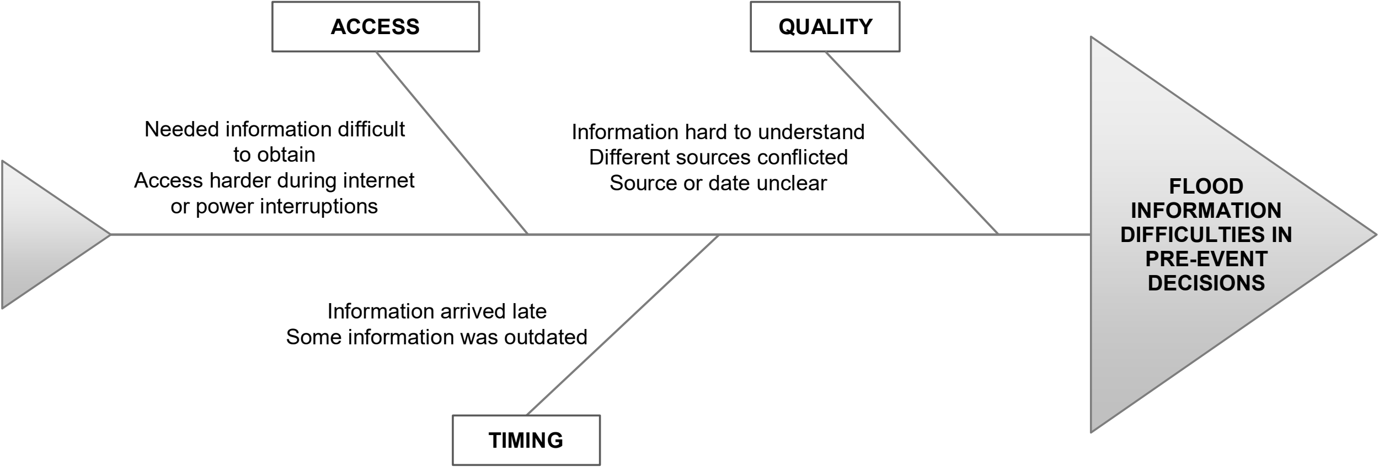
Appendix Figure 1. Fishbone Diagram of Flood-Information Difficulties
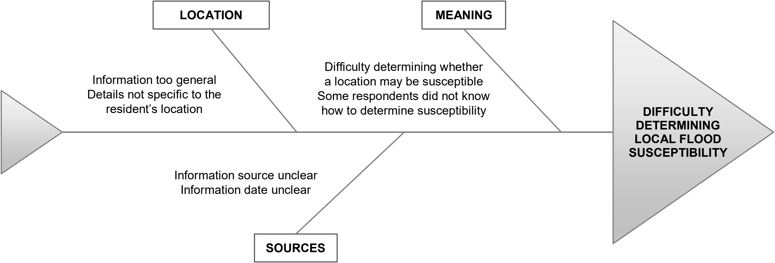
Appendix Figure 2. Fishbone Diagram of Local Flood-Susceptibility Difficulties
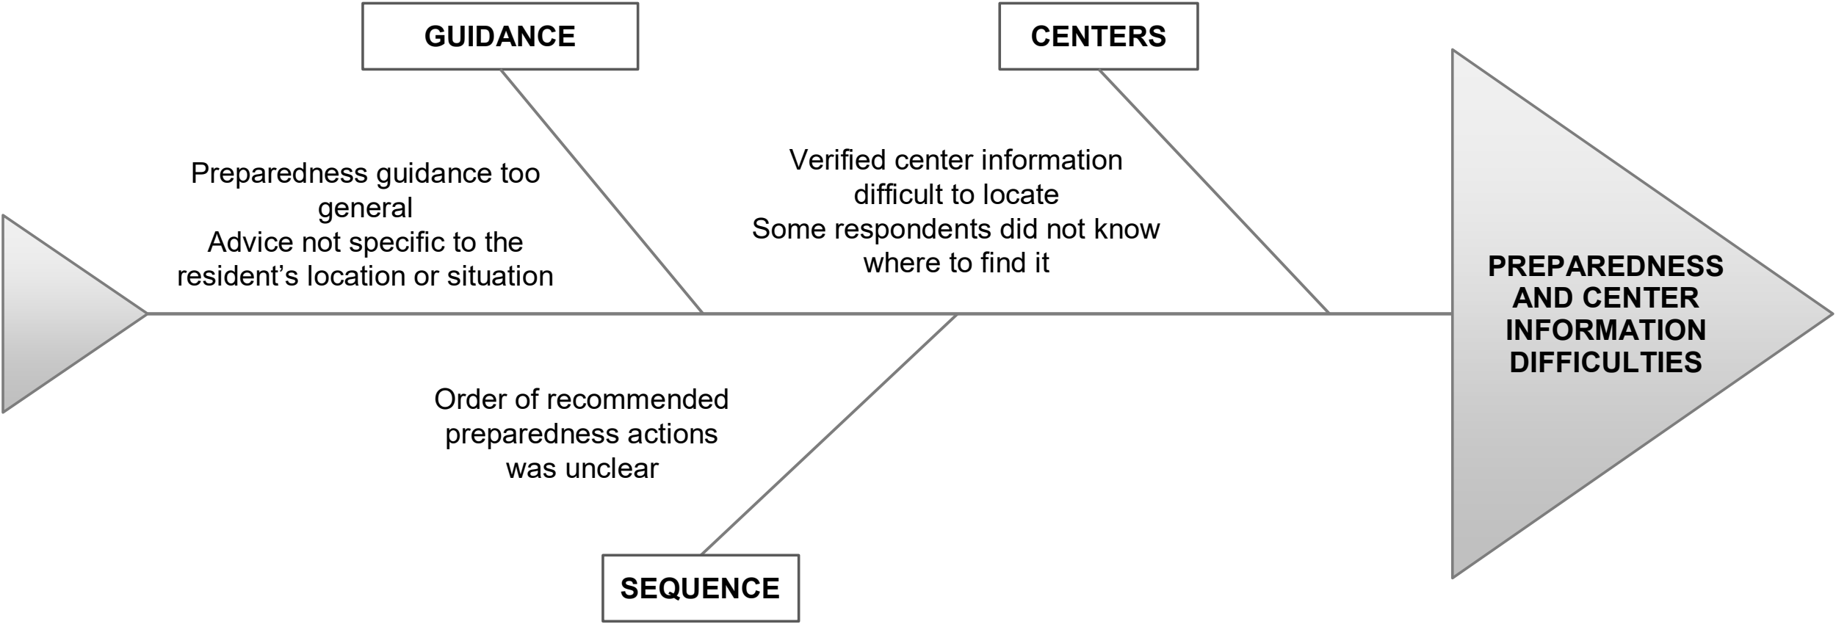
Appendix Figure 3. Fishbone Diagram of Preparedness and Center-Information Difficulties
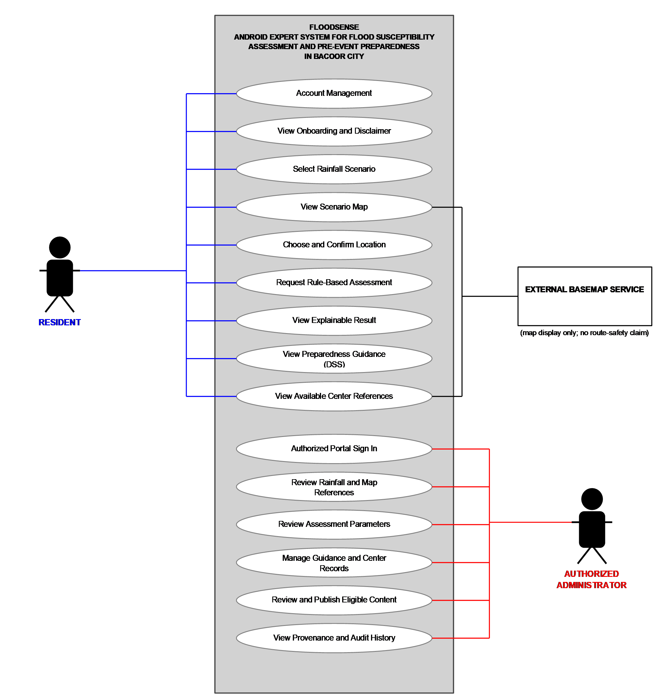
Appendix 2. Use Case Diagram

Appendix Figure 4. Use Case Diagram of FloodSense
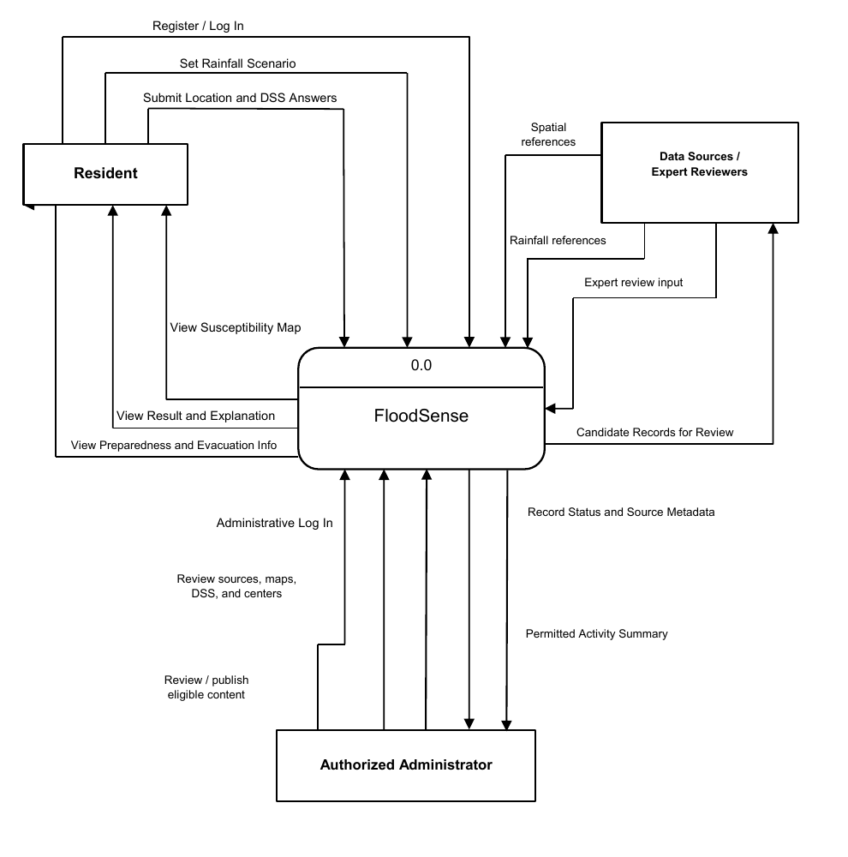
Appendix 3. Context Diagram

Appendix Figure 5. Context Diagram of FloodSense
Appendix 4. Initial Resident Needs-Assessment Questionnaire, Blank Copy
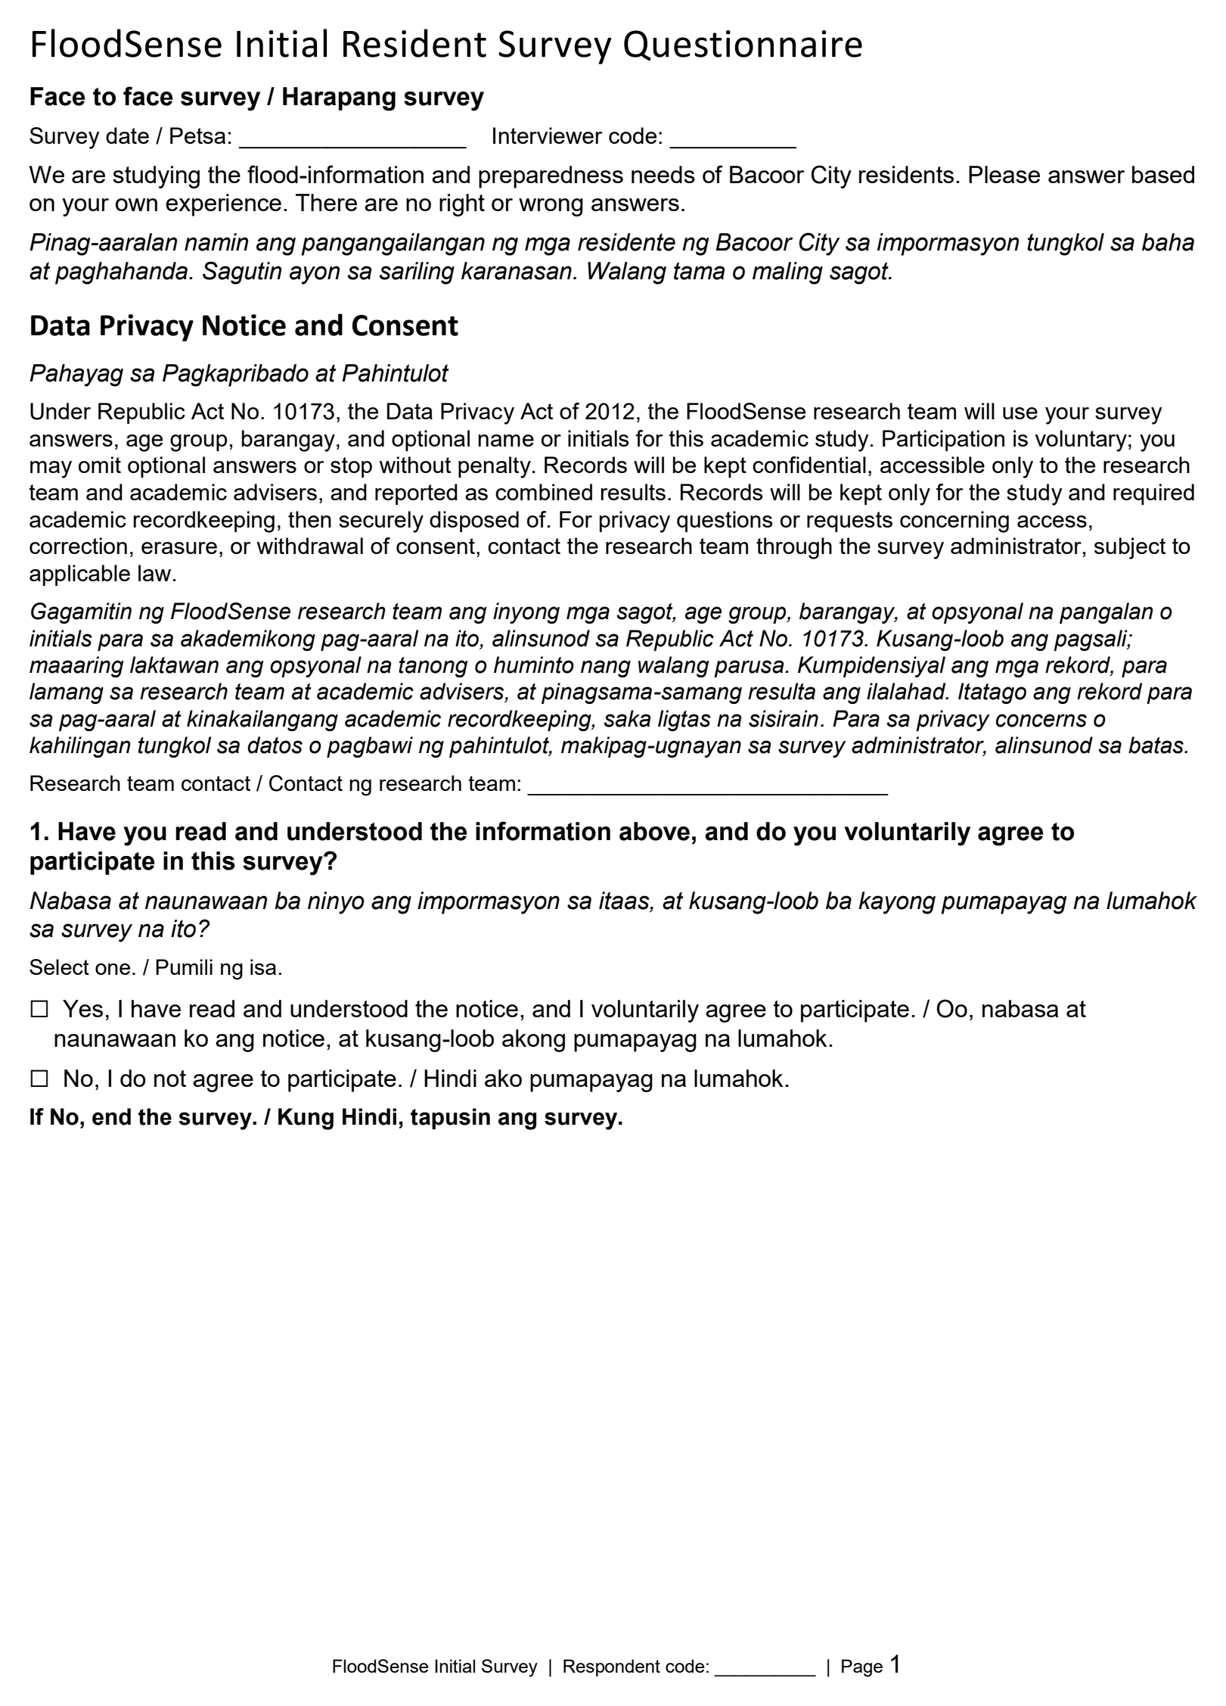
This blank form reproduces the question set represented in the October 11, 2026 response export; it contains no respondent answers.

Appendix Figure 6. Questionnaire Page 1 of 10
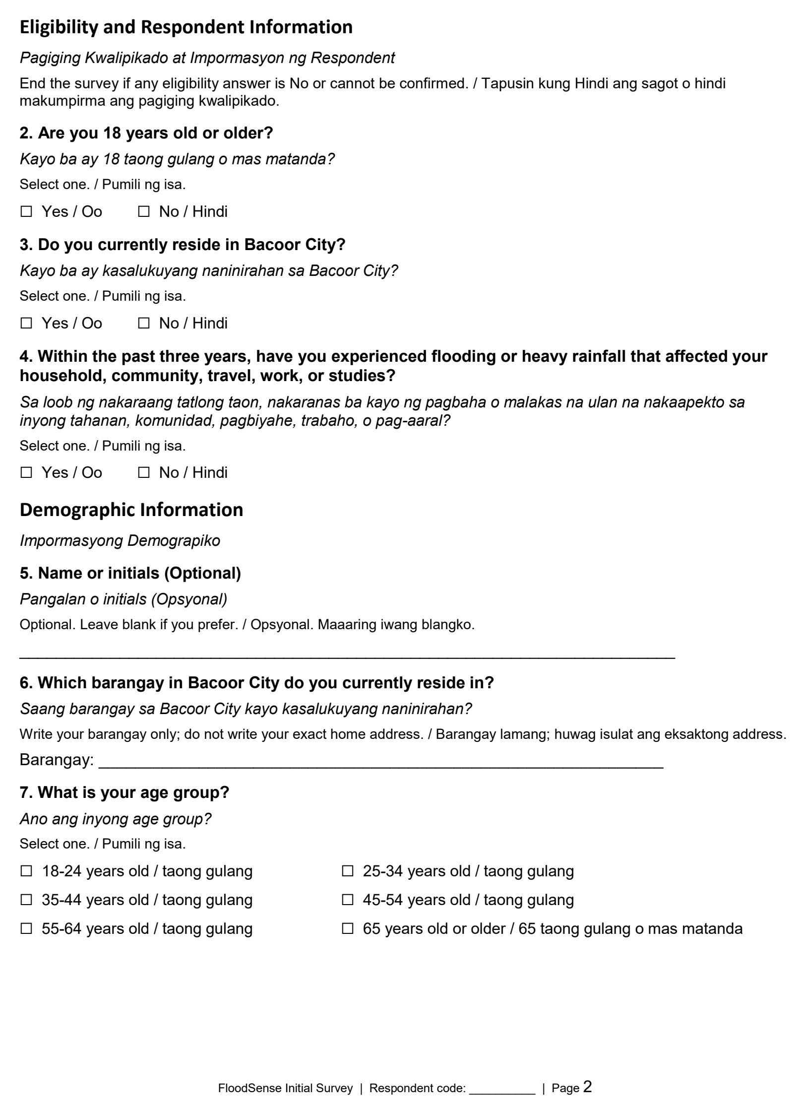
Appendix 4. Continued

Appendix Figure 7. Questionnaire Page 2 of 10
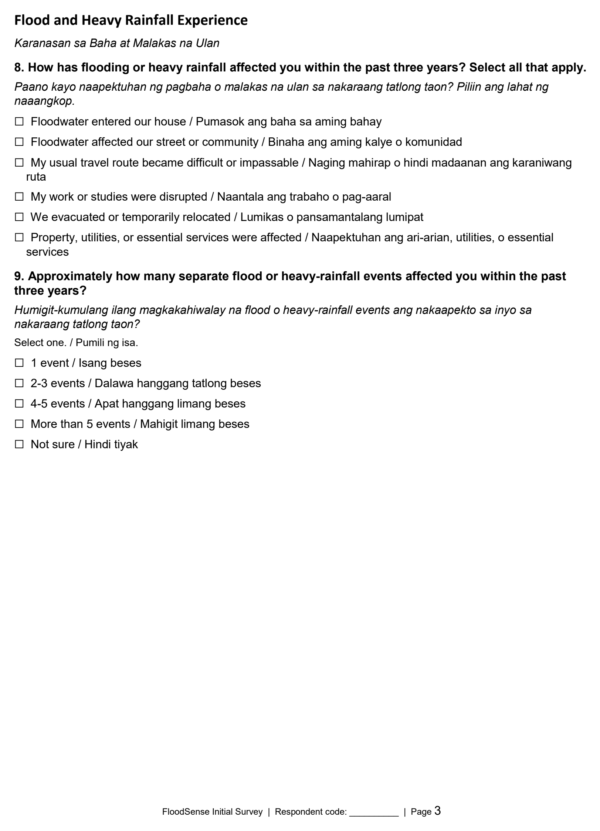
Appendix 4. Continued

Appendix Figure 8. Questionnaire Page 3 of 10
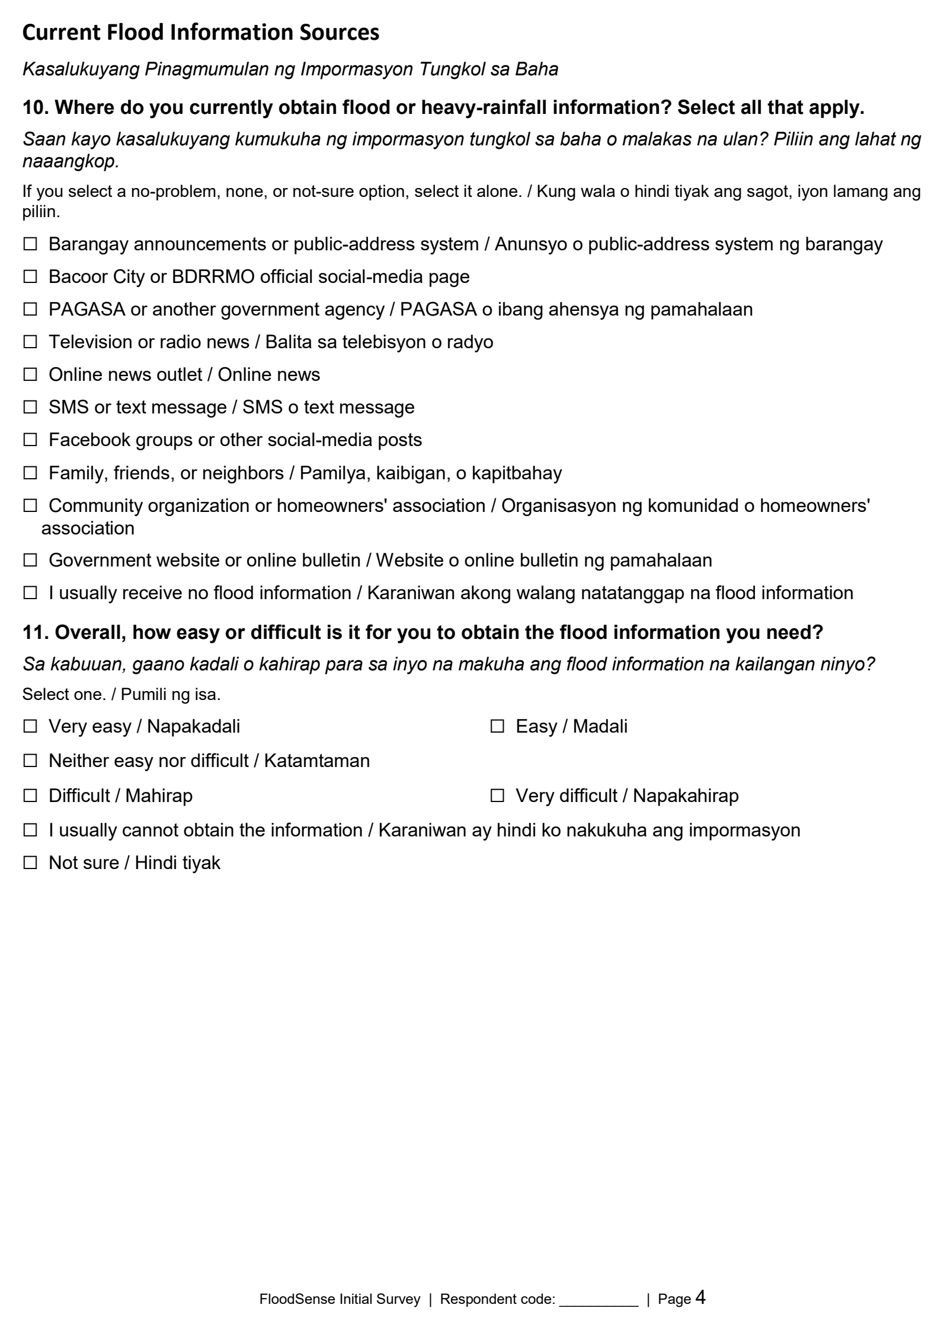
Appendix 4. Continued

Appendix Figure 9. Questionnaire Page 4 of 10
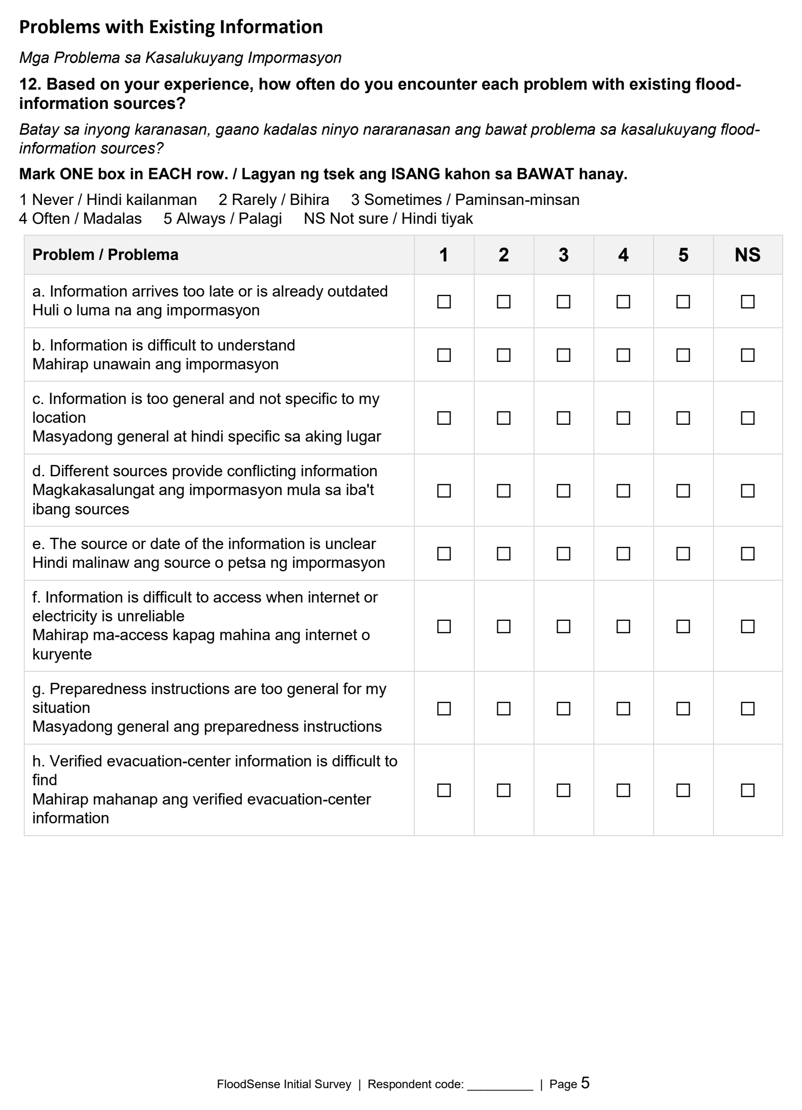
Appendix 4. Continued

Appendix Figure 10. Questionnaire Page 5 of 10
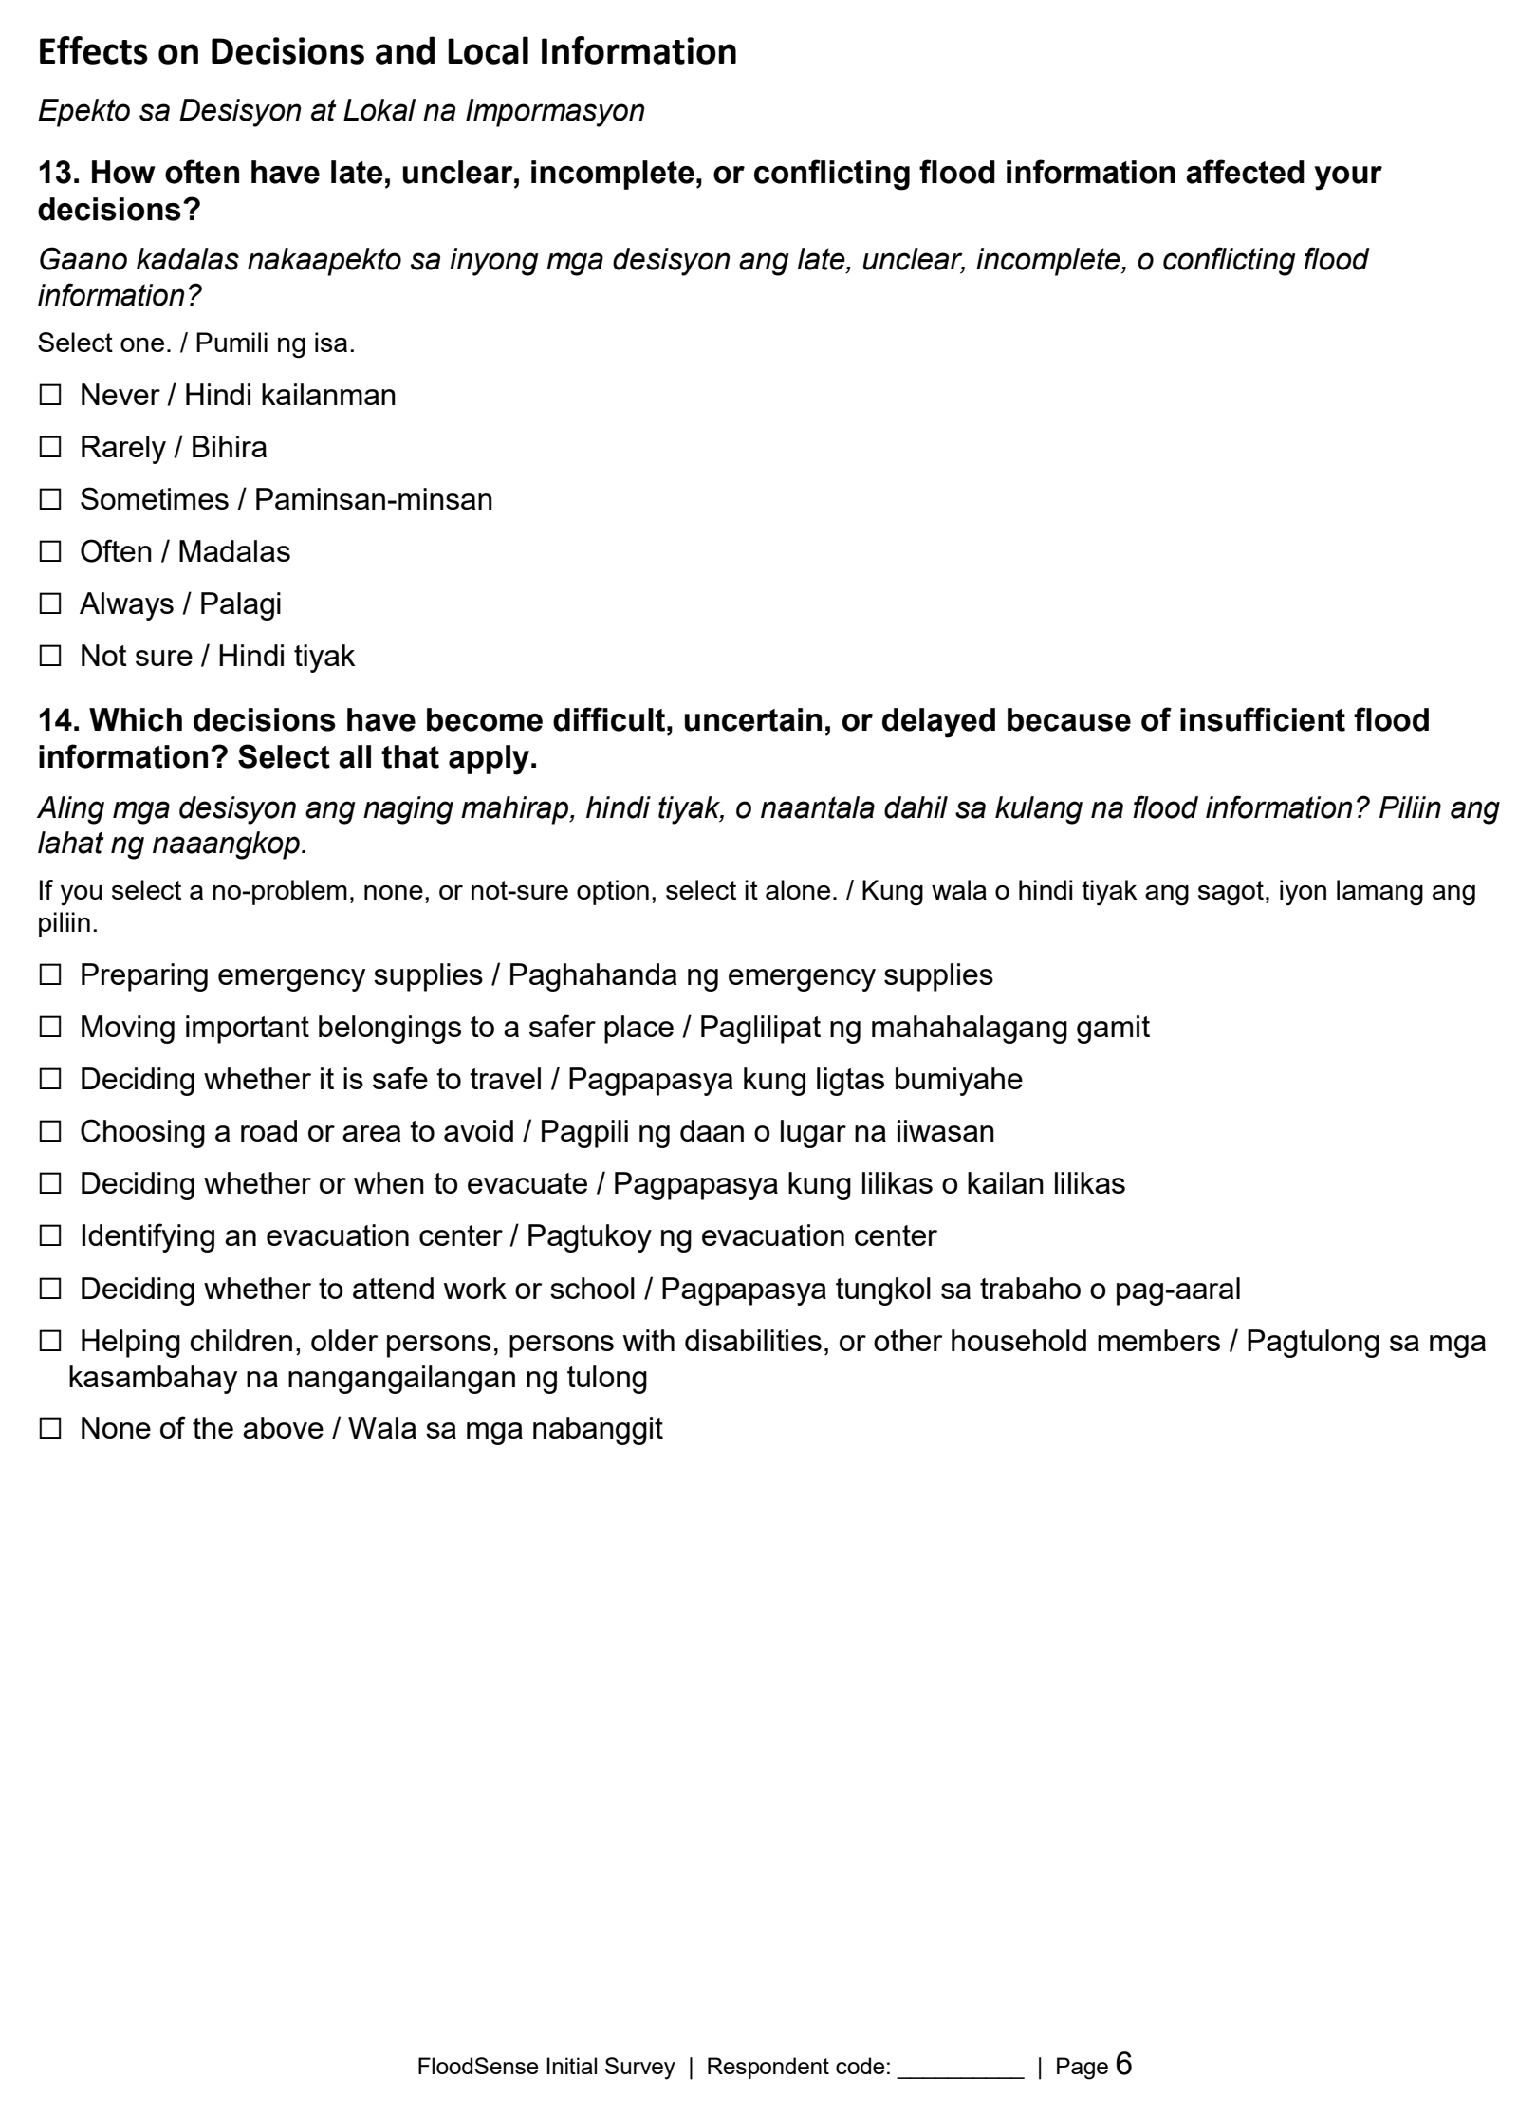
Appendix 4. Continued

Appendix Figure 11. Questionnaire Page 6 of 10
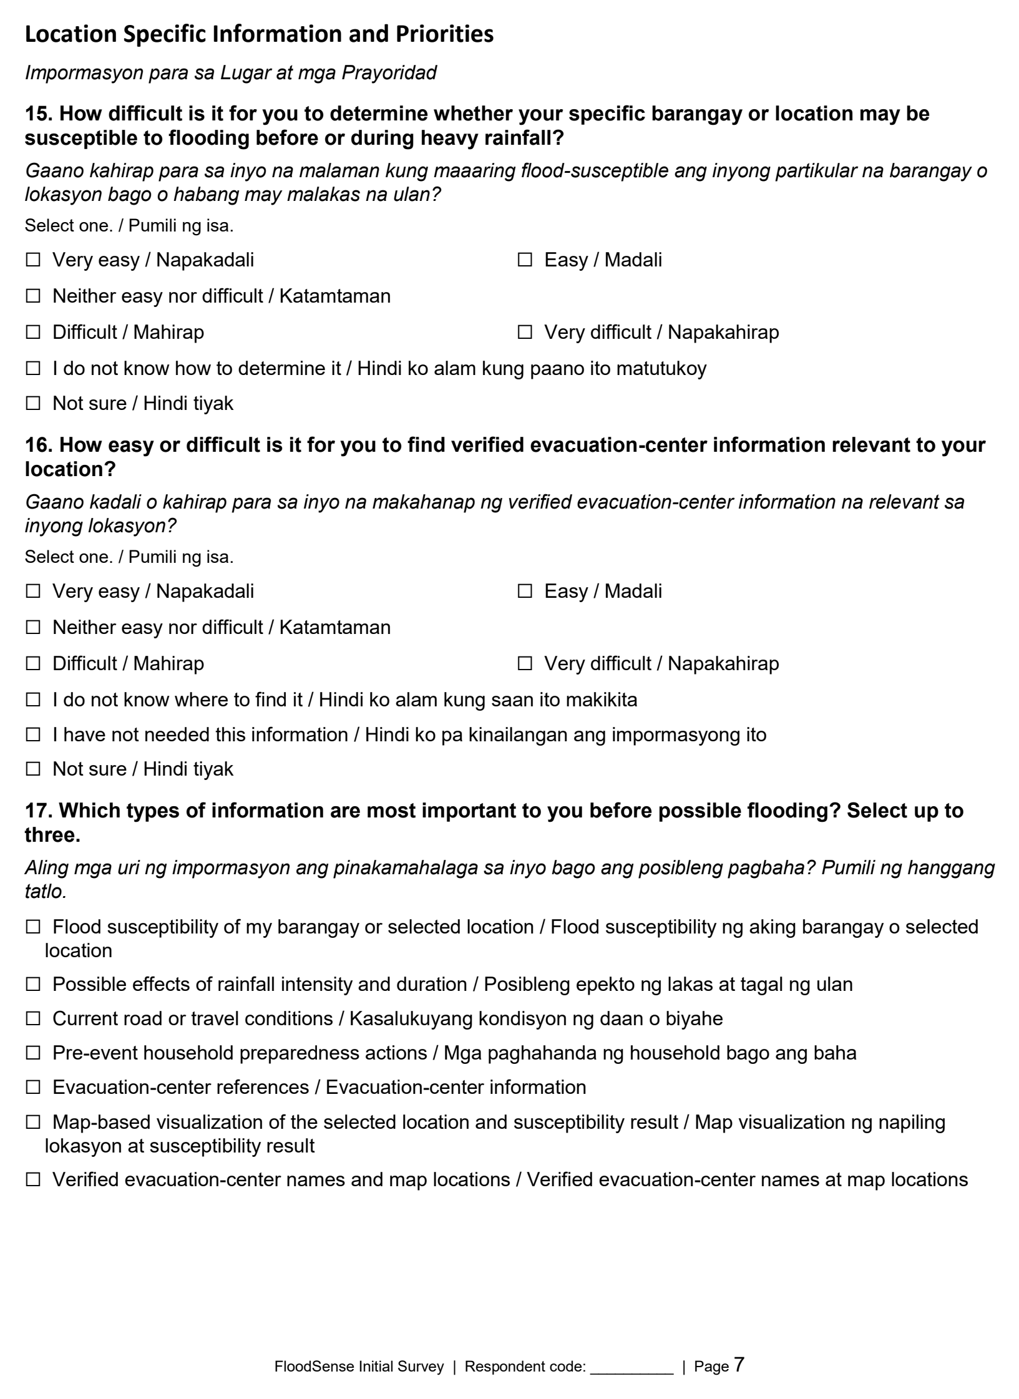
Appendix 4. Continued

Appendix Figure 12. Questionnaire Page 7 of 10
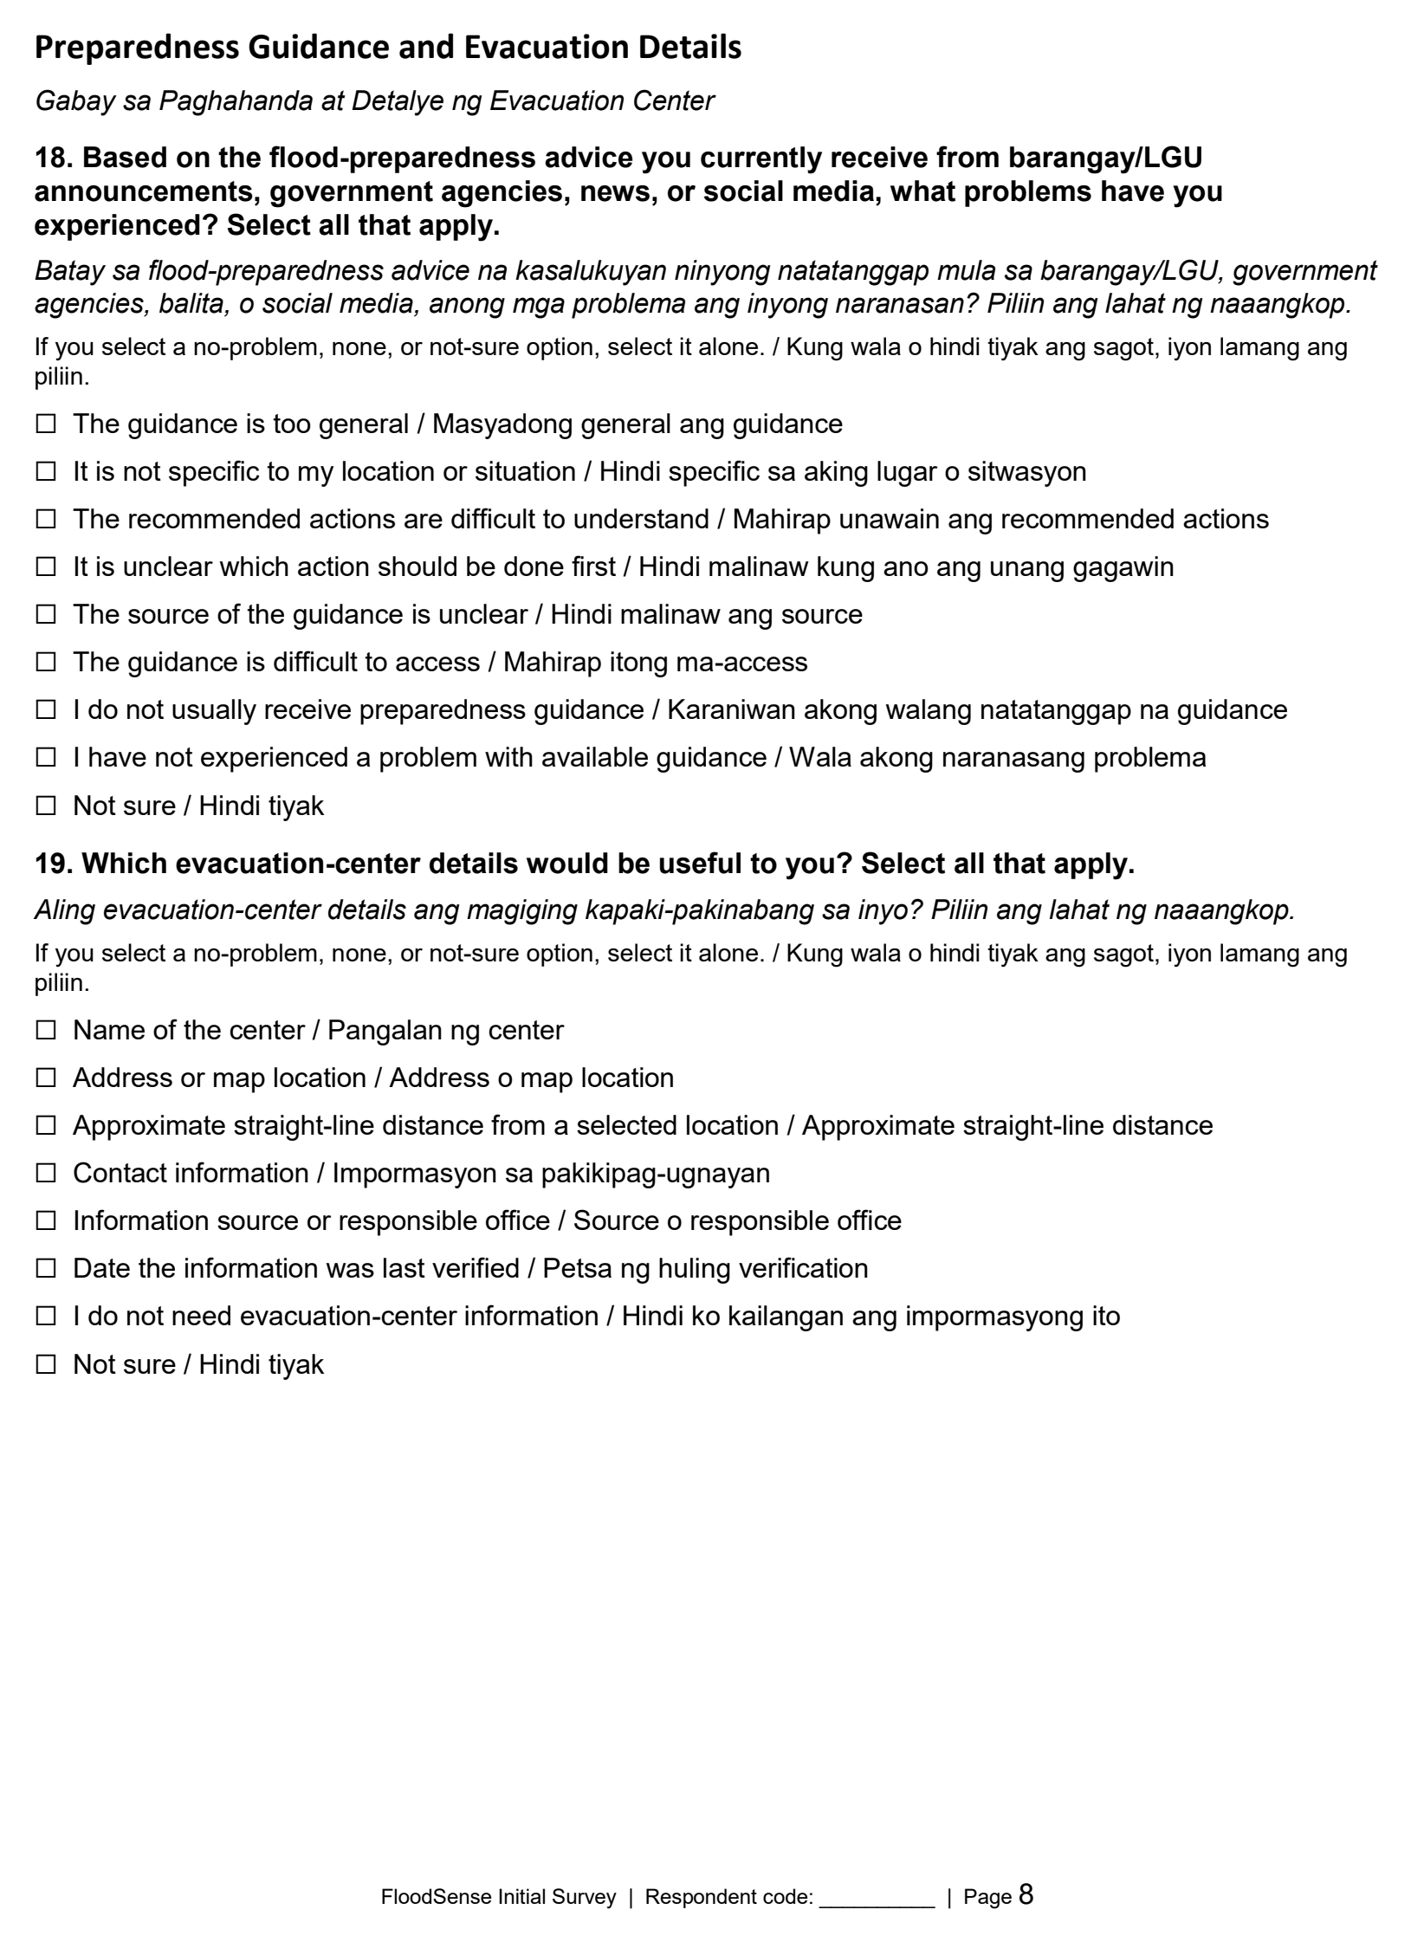
Appendix 4. Continued

Appendix Figure 13. Questionnaire Page 8 of 10
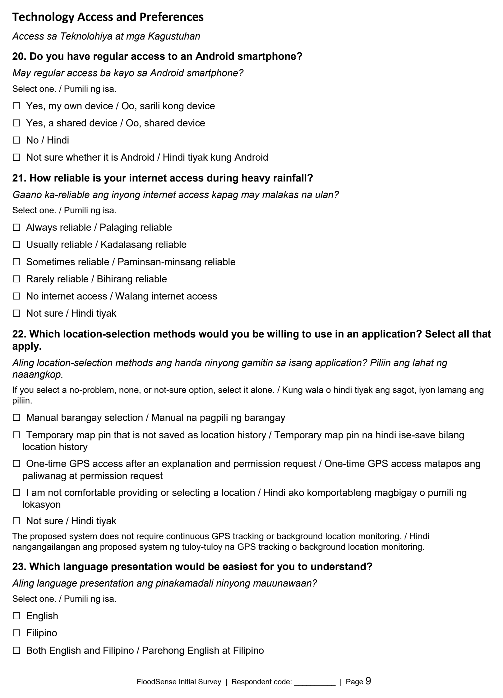
Appendix 4. Continued

Appendix Figure 14. Questionnaire Page 9 of 10
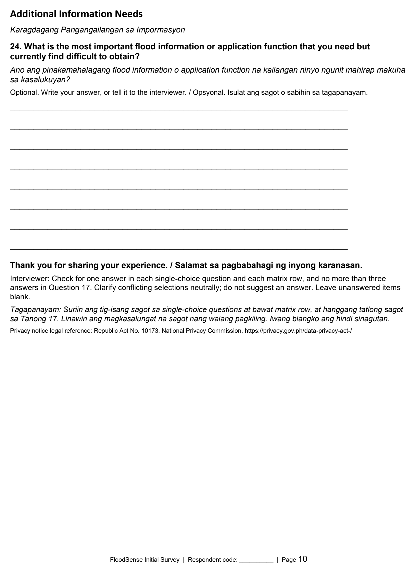
Appendix 4. Continued

Appendix Figure 15. Questionnaire Page 10 of 10

Appendix 5. Documented Development Iterations
Appendix Table 3. Documented Development Iterations, September 18-October 2, 2026
PERIOD | DEVELOPMENT INCREMENT | RECORDED ISSUE OR DEPENDENCY | RECORDED REVISION | TESTING RECORD AND OUTCOME
September 18-20, 2026 | Administrative and location foundations | Nearest-center presentation still depended on the production service and client adapter. Governed parameter editing remained a separate dependency. | Added administrative review and maintenance workflows, source and center controls, foreground GPS and barangay resolution, and nearest-center presentation components. | The report records backend and mobile regression coverage. At this checkpoint, nearest-center presentation did not establish completed production integration.
September 21-22, 2026 | Nearest-center integration | The preceding increment lacked the complete production API/client connection. Authorized center records were needed for populated acceptance checks. | Established the request/response contract and nearest-center endpoint; connected the Flutter HTTP adapter, parser, warnings, and failure handling. | Historical record: 175 passing Flutter tests and an empty-response integration check. Populated device acceptance remained dependent on authorized center records.
September 22-27, 2026 | Resident access and map refinement | Authentication retained external-service configuration dependencies. Susceptibility-preview material was provisional. No specific reviewer defect was quoted. | Added resident access and onboarding, account preferences, unified assessment mapping, coverage treatment, structured preparedness, and optional Mapbox presentation. | The report records validation and configuration-test work. These changes did not establish approved susceptibility data, completed user evaluation, or deployment.
September 30-October 1, 2026 | Administrative navigation refinement | Interface and navigation refinements were documented; a specific user complaint or reviewer quotation was not recorded. | Separated Overview and Reports; refined collapsed navigation, accessible tooltips, keyboard behavior, and sidebar account controls. | Historical record: 147 passing portal tests and responsive browser checks associated with the Reports work. Test results were not rerun for the accomplishment report.
October 2, 2026 | Map provenance and test isolation | Display sources, demonstration content, provisional material, and integration-dependent datasets needed distinct presentation. Test configurations were isolated. | Refined map-camera behavior; added the resident Data Sources screen; separated map-provider and preview settings in tests. | The report documents source-transparency and test-configuration changes. It does not establish City approval of the displayed data.
October 2, 2026 | Preparedness and reviewed imports | Content approval, publication, and populated authorized records remained separate requirements. | Expanded versioned preparedness flows, controlled editing and publication workflows, bulk review, and validated CSV/XLSX center imports that create draft records. | Historical final-commit record: 783 passing backend tests, 228 passing Flutter tests, analysis and service checks. Import infrastructure did not establish an official populated dataset or production deployment.

